A2 - Prototype

Name: Jingyi Ouyang

ID: A53108909

Name: Weihan Jiang

ID: A92089193

Name: Derrick Lieu

ID: A12075300

**Point of View**

Some people have important hobbies they want to keep track of but lack the motivation or the tools to achieve this. There should be a simple, efficient, and rewarding way to do this to allow them to realize the important insights into their life.

**Storyboard**

#1

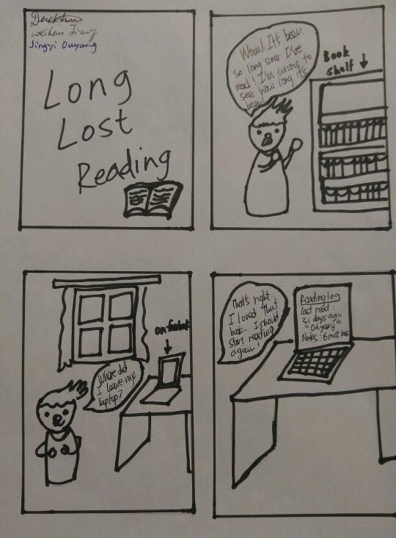

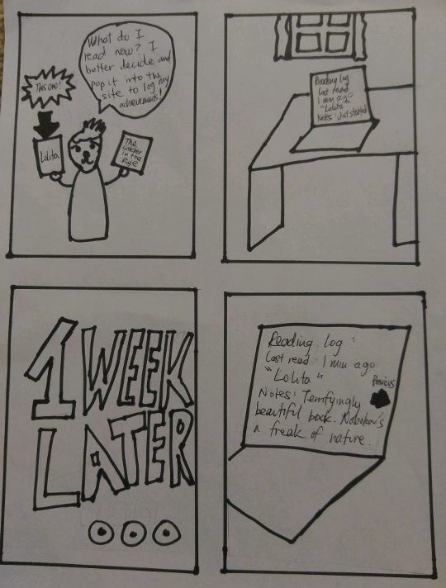

In this scenario user could keep track of his reading history.

#2

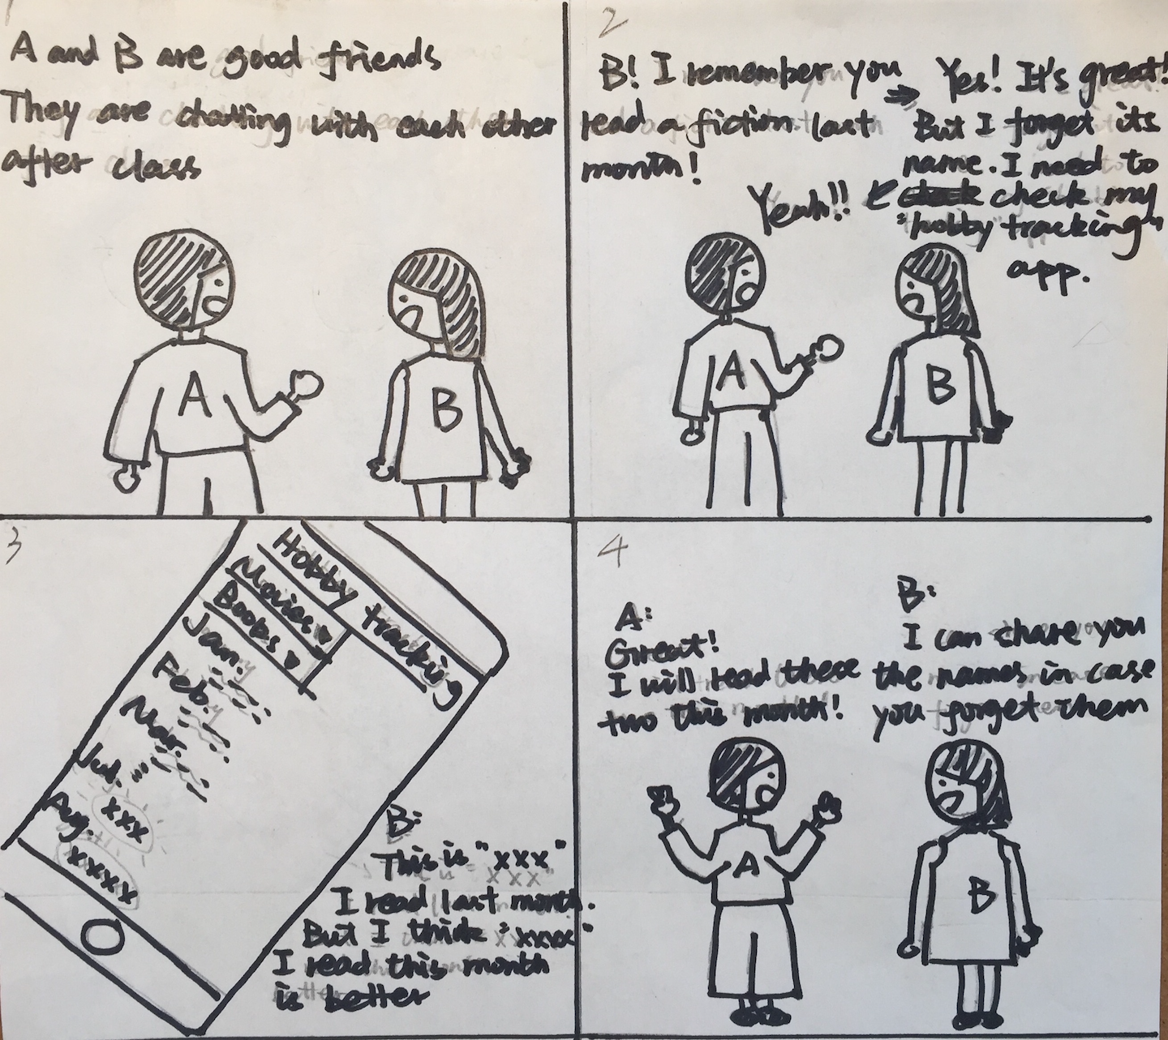

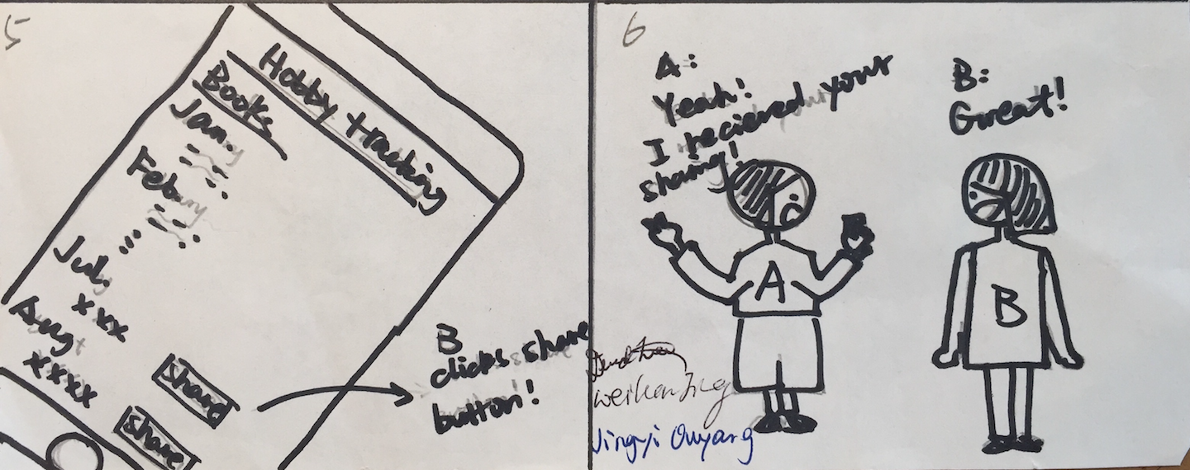

User here could use the website to see the books she read and share them with friends.

#3

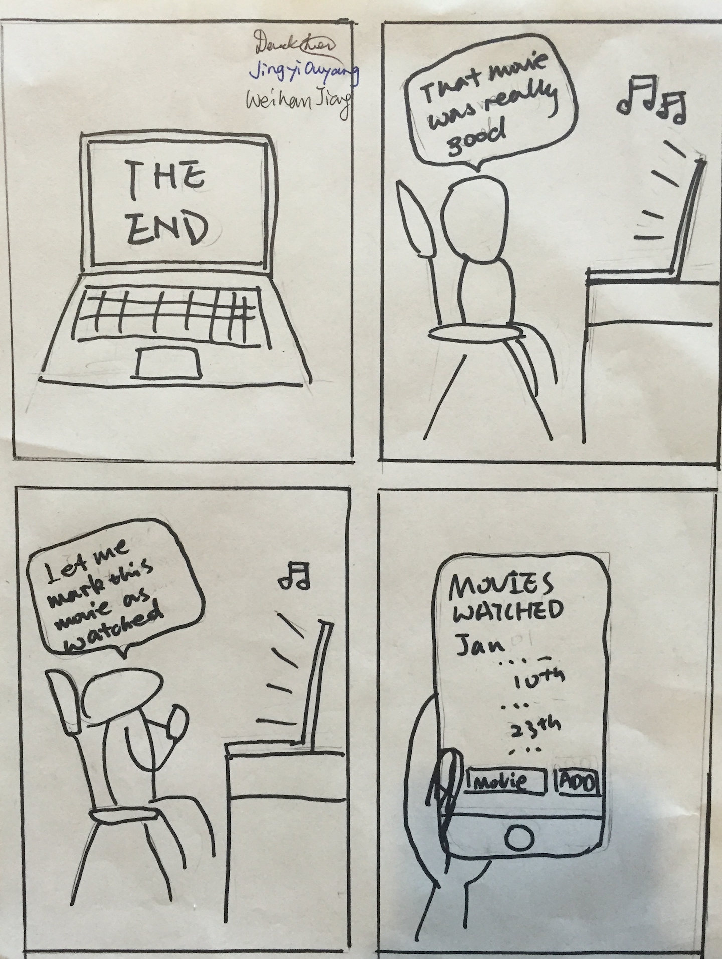

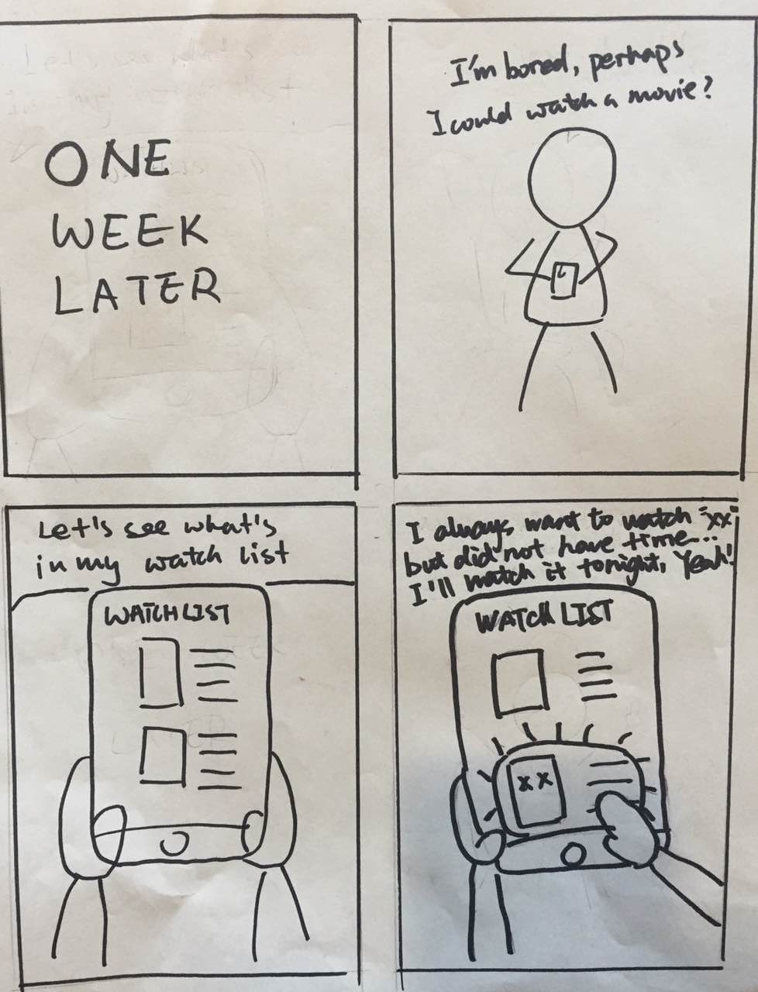

The user here uses the website to keep his movie watchlist so that he knows what to watch when he wants a movie. If he watched the movie, he could remove it from watch list and add it into watched list.

Prototype

#1.

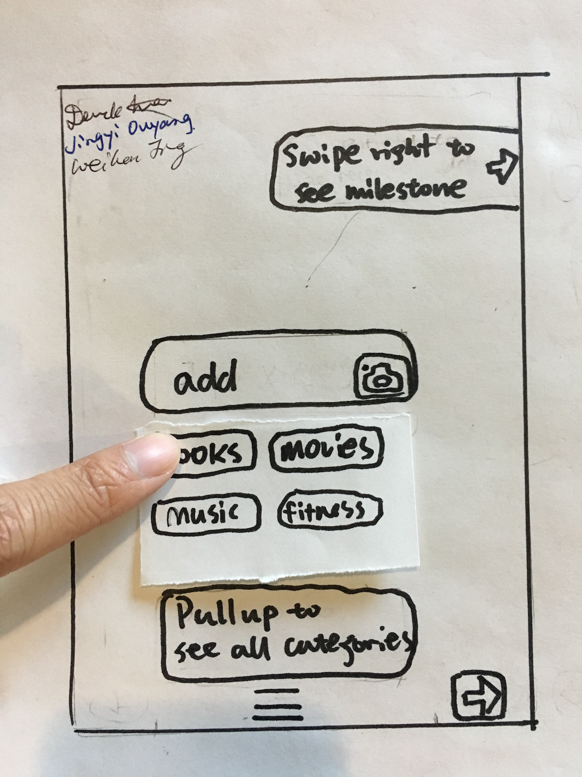

The user is adding a book into the “book” category.

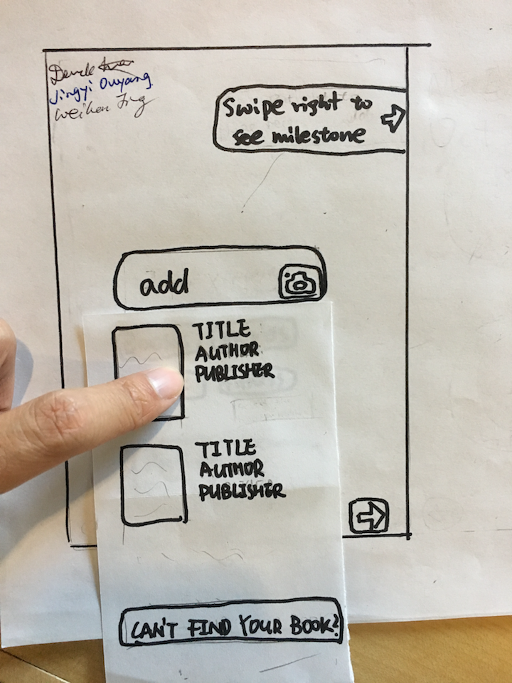

The app searches the book automatically and shows the relevant results.The user finds the right one and clicks it!

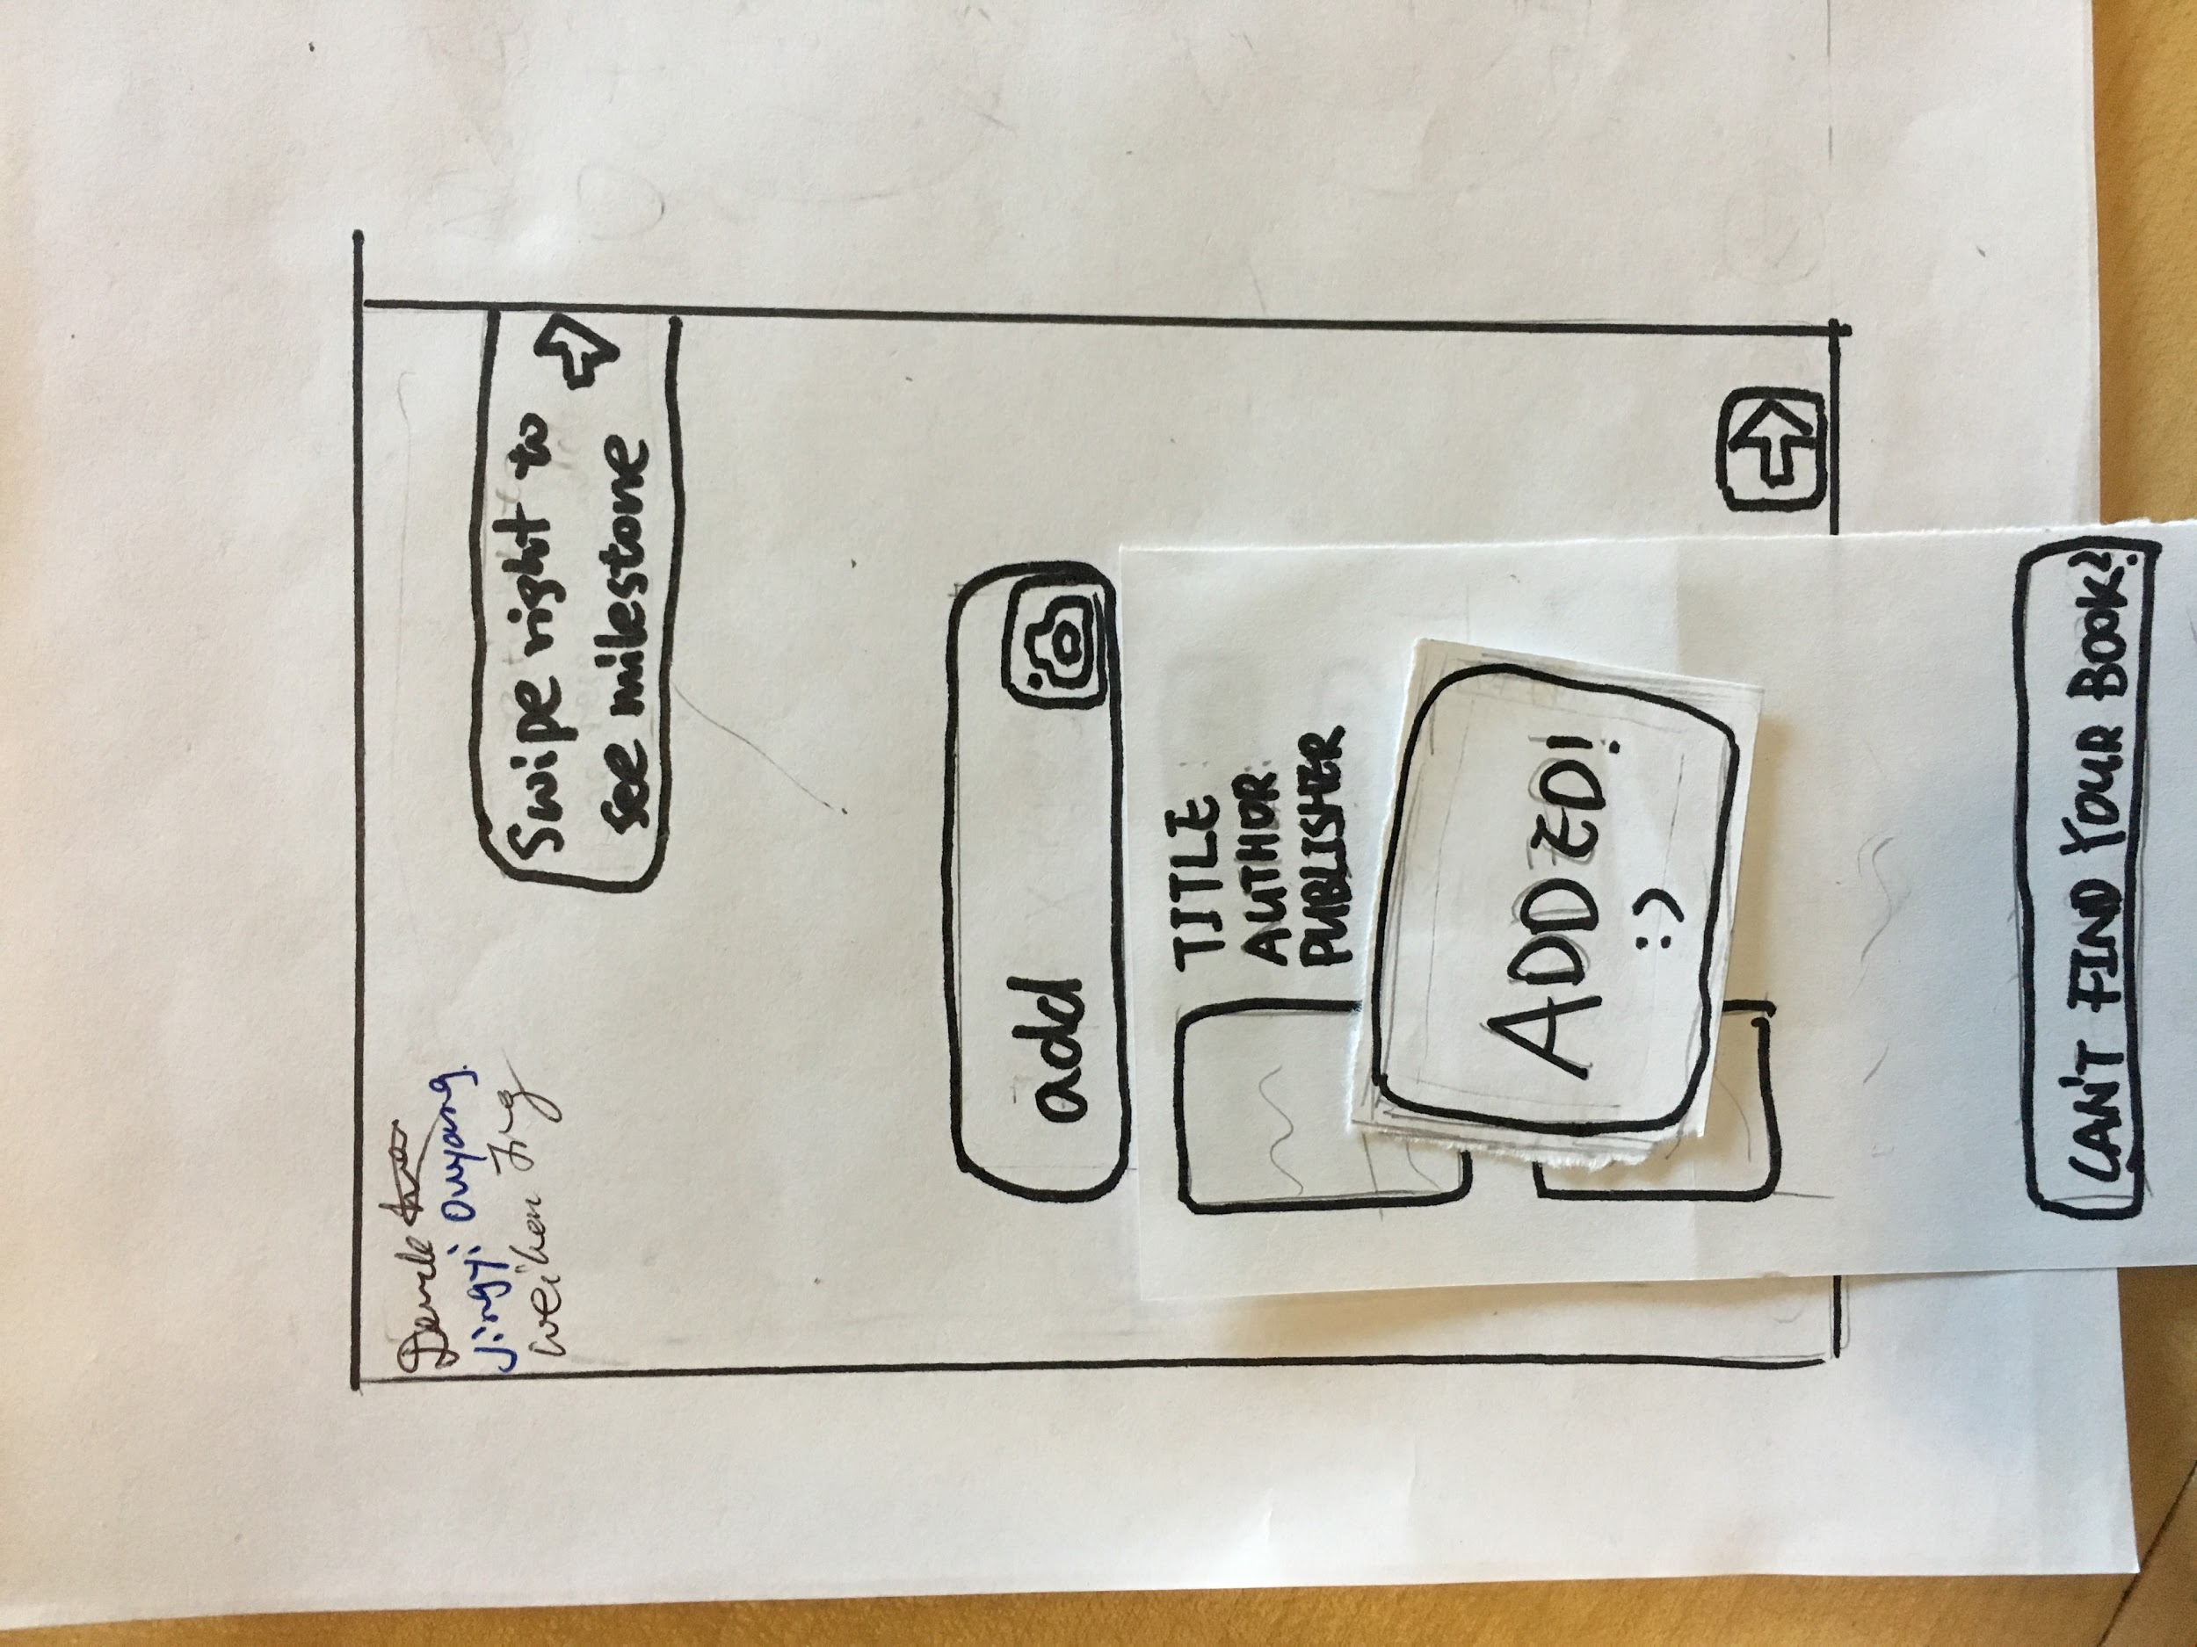

The book has been successfully added into “Book” list.

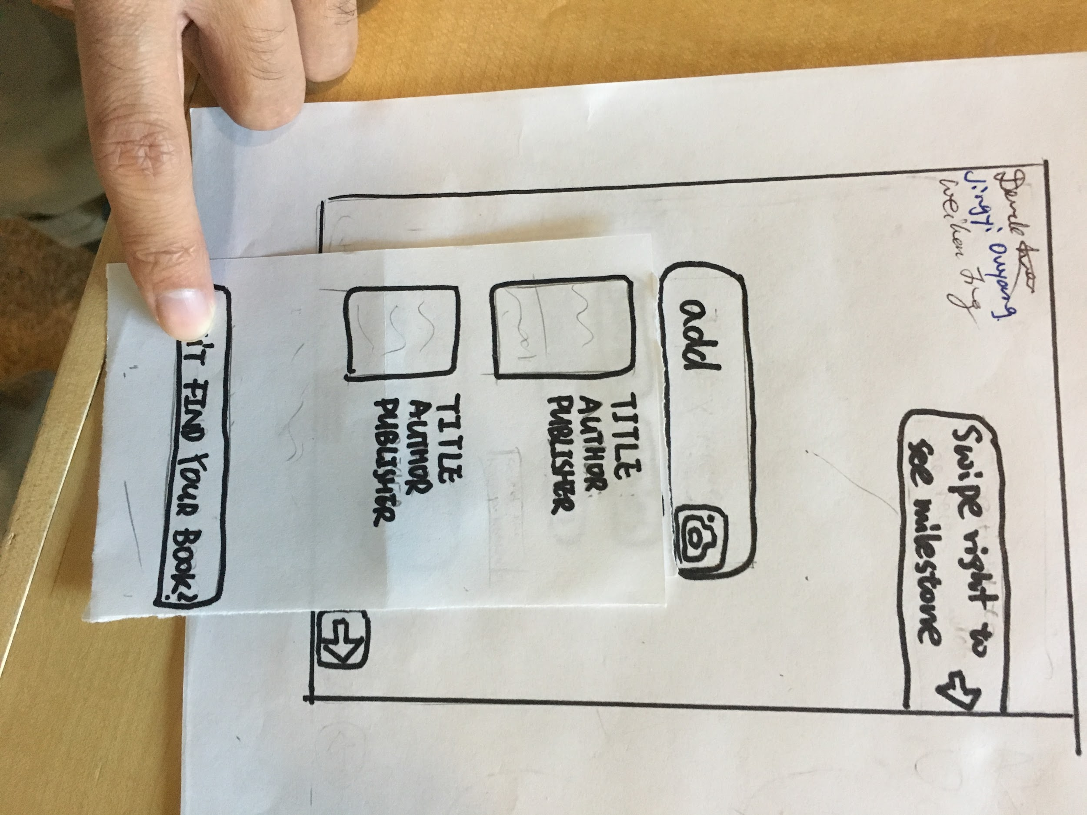

Sometimes users can not find the book in the results. They can click “can’t find your book?” and then they could enter the info manually.

Title will be automatically filled based on user input. They could add now and fill info later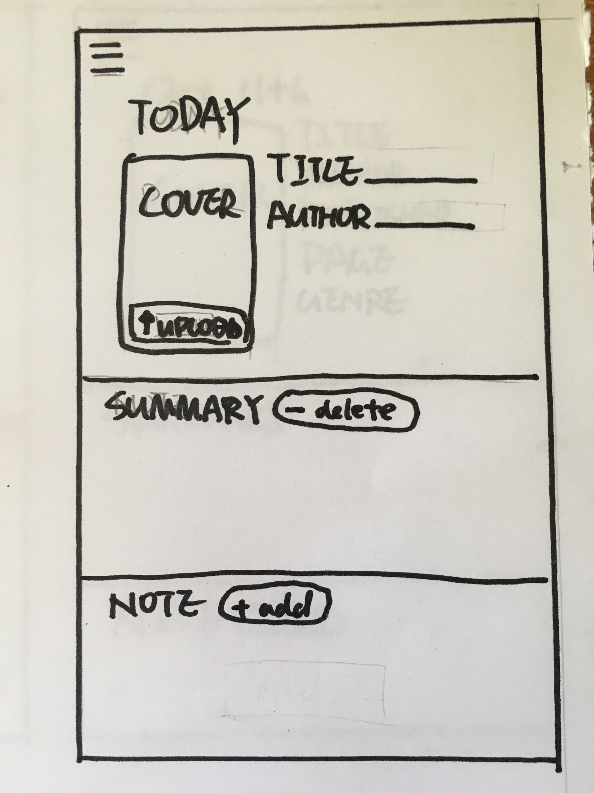

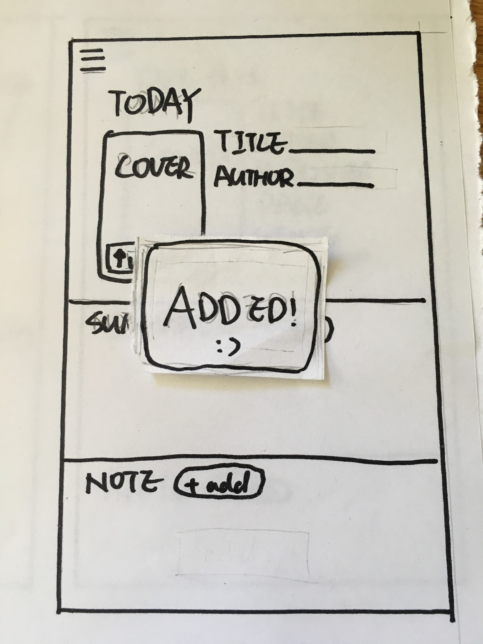

Successfully added item

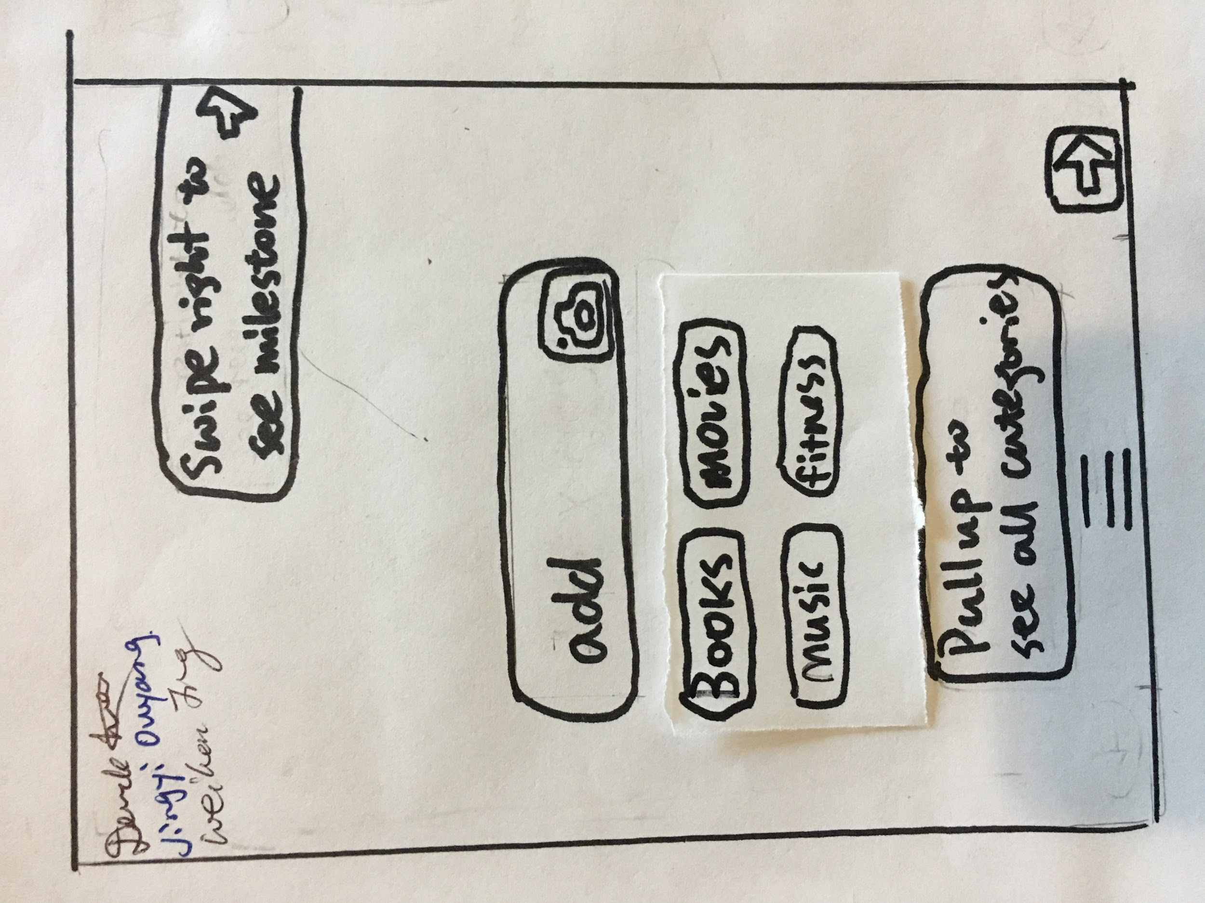

“Pull up” button is at the bottom. The user can pull it up to get into categories

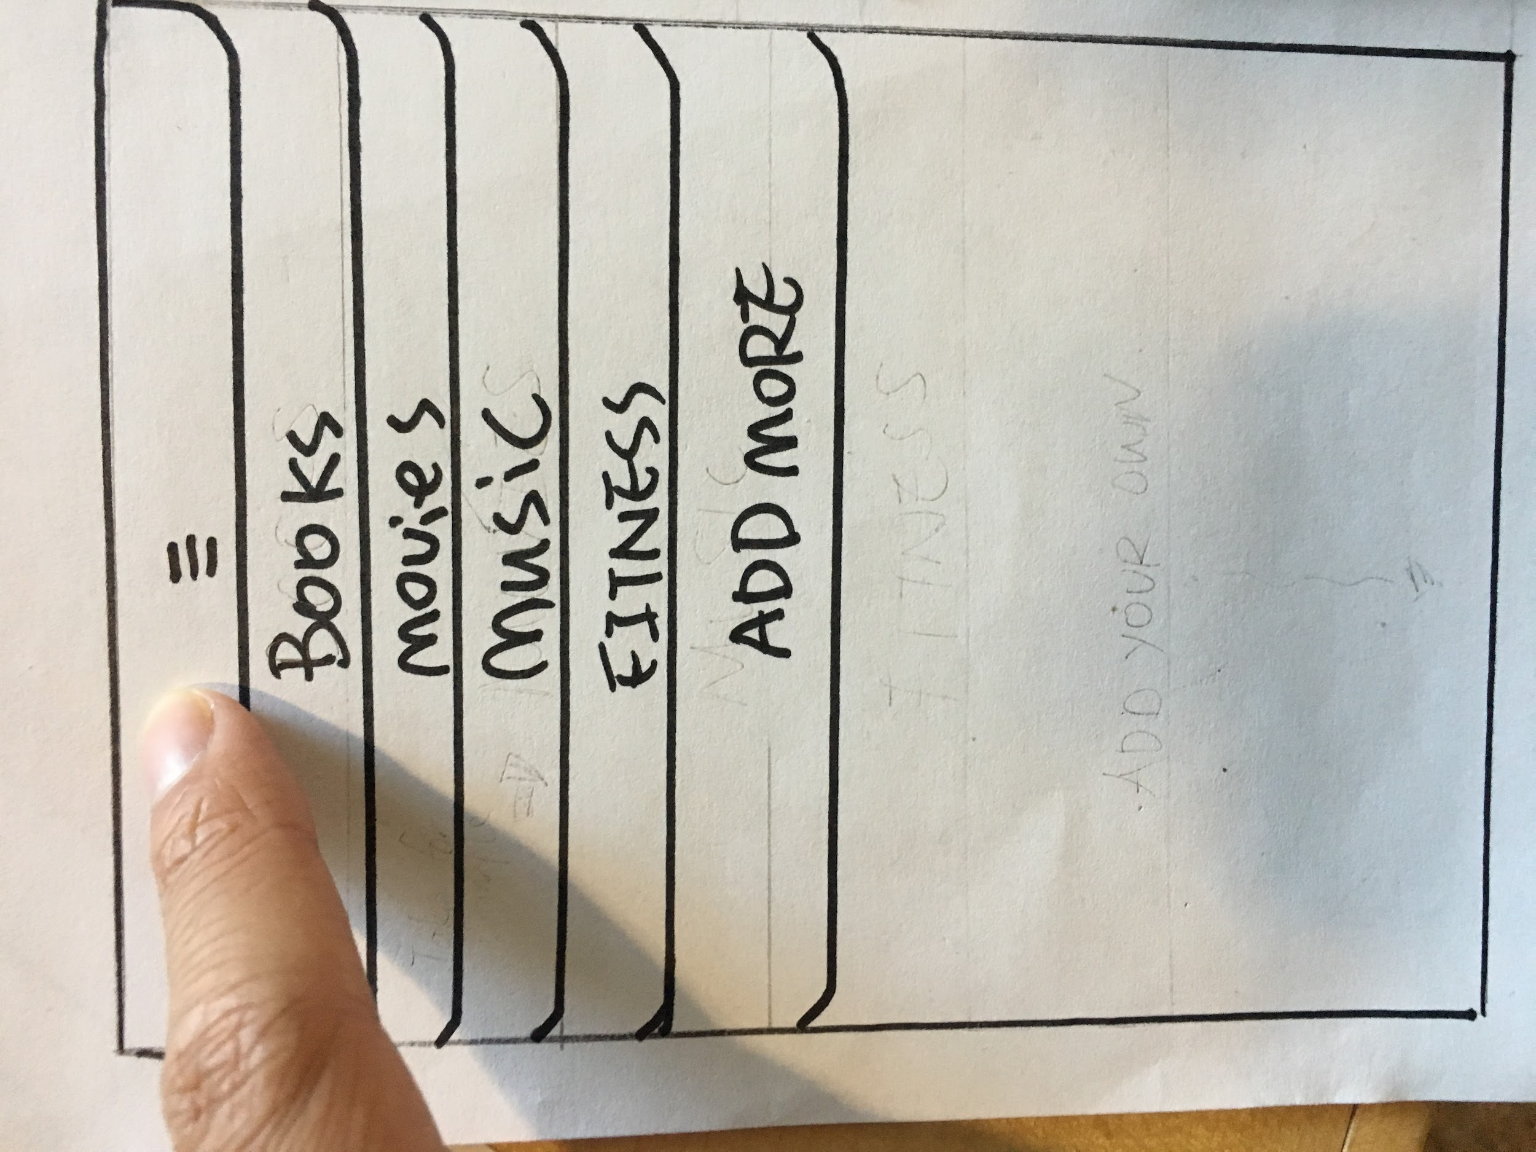

This is the categories page. The user can click the one they want to get in.

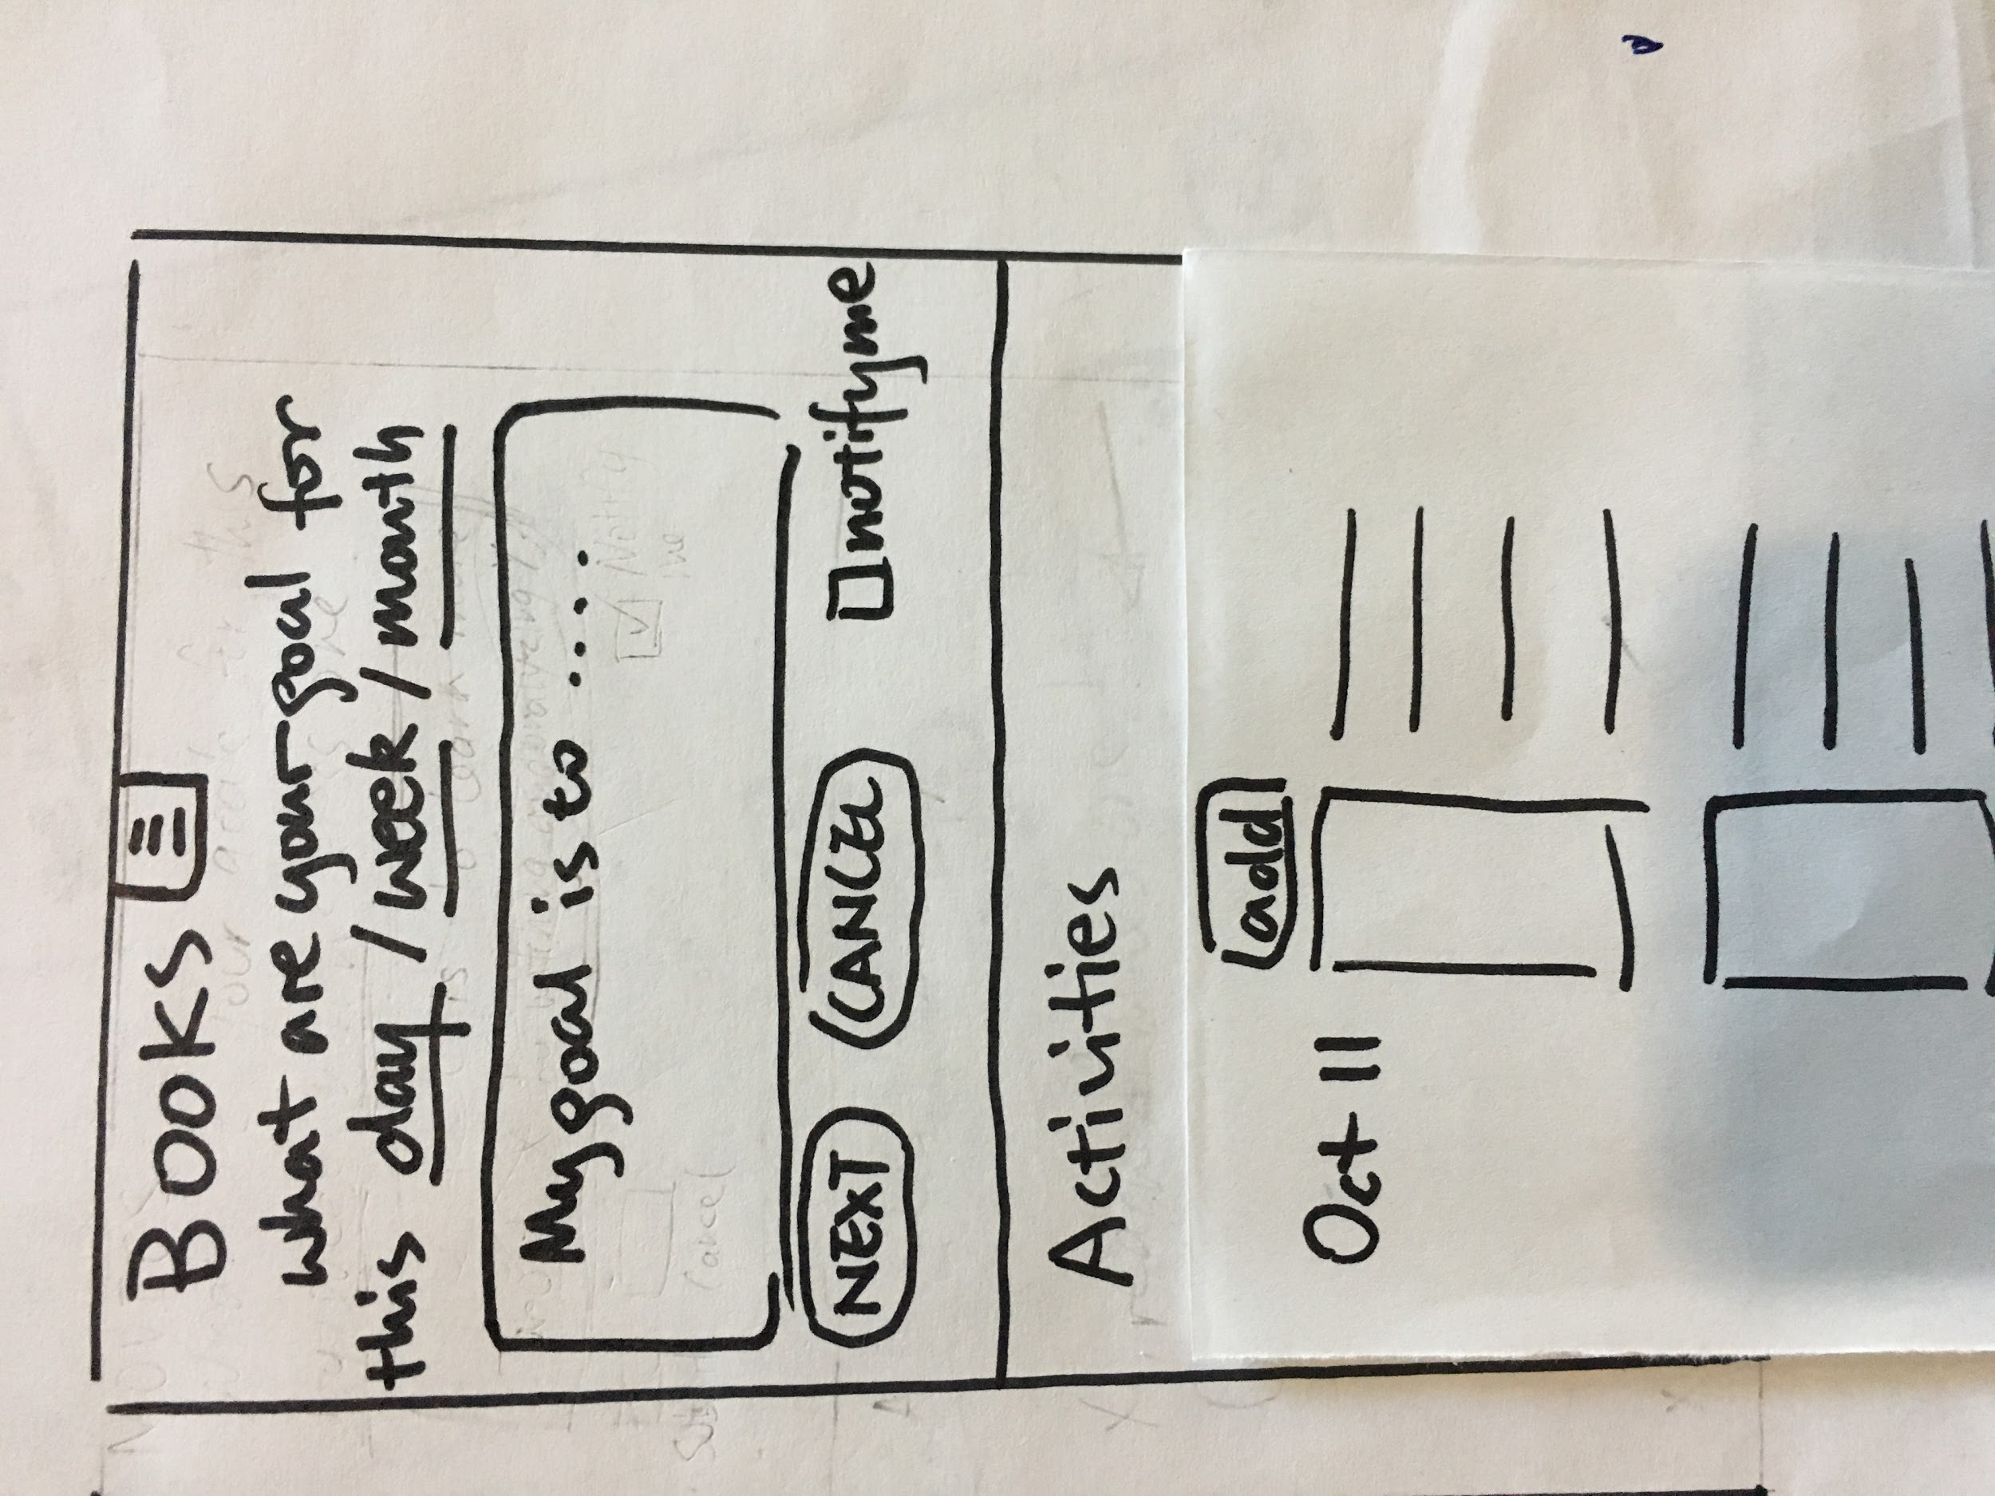

The user now is in “Book” page. At the top, the user can add their goals. The books the user

added are shown at the bottom if no goals are set. To set goals, simply fill out the info above and click “next” to fill checklist. User could also set notification.

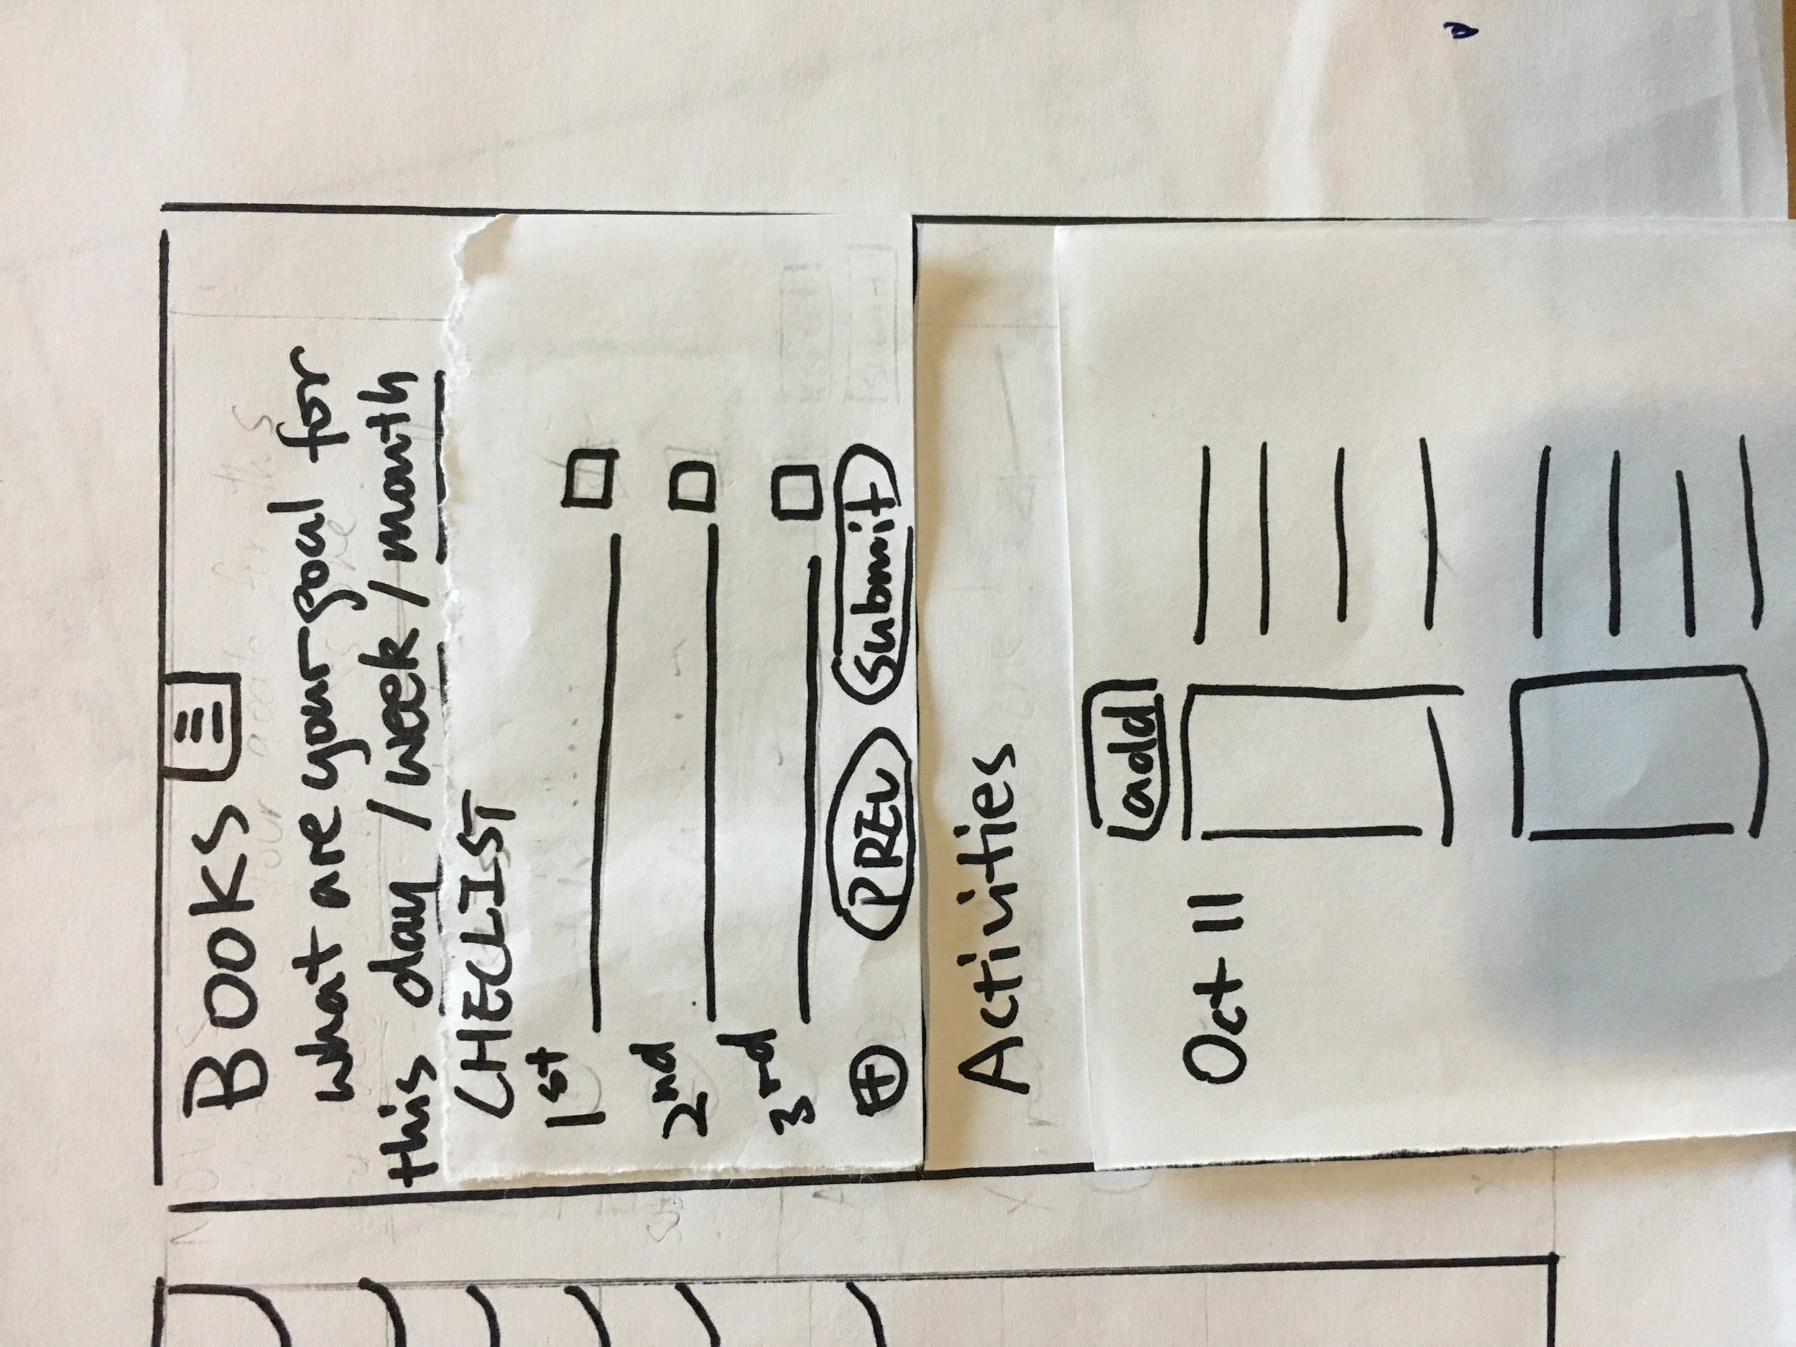

Users can add the things they are going to do to achieve the goals into checklist. Don’t forget click “submit” button.

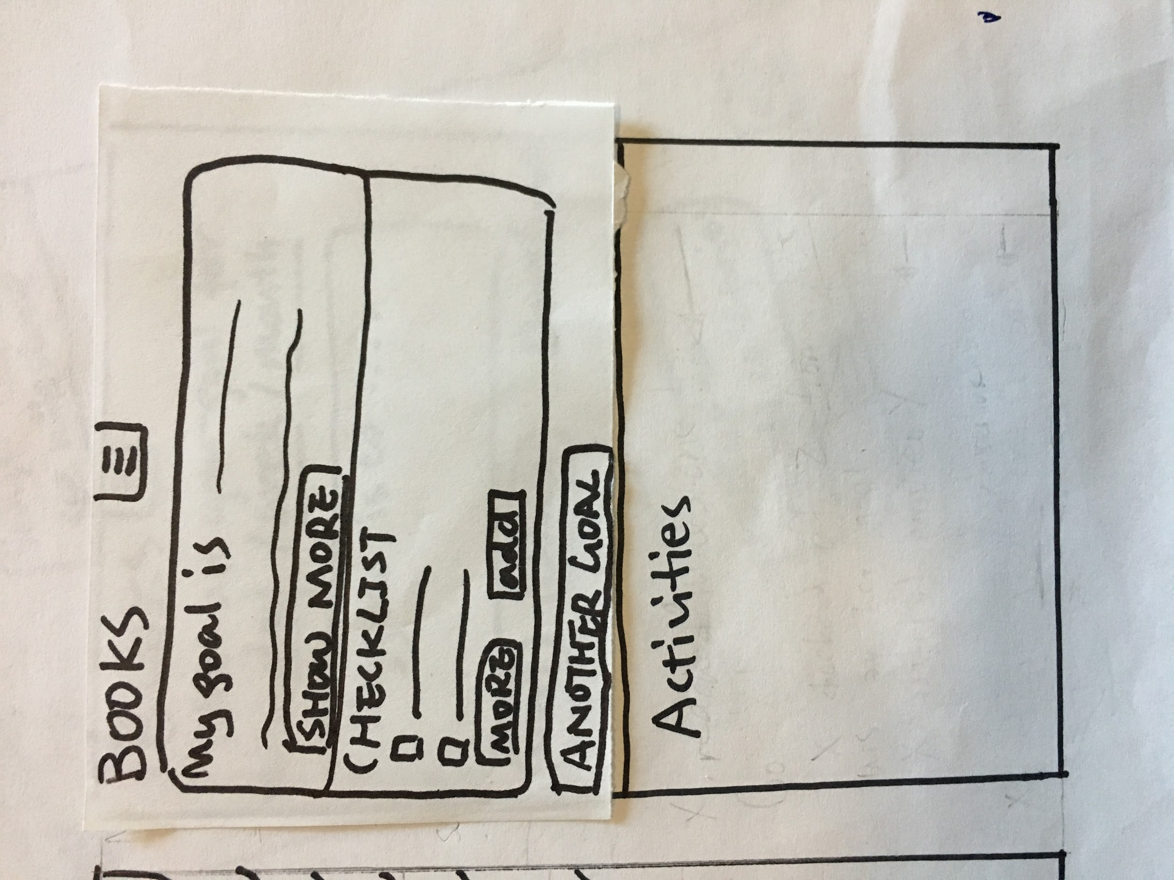

The user has set his goals! if the user wants to add another goal, just click “another goal”. The history is also changed to display activities.

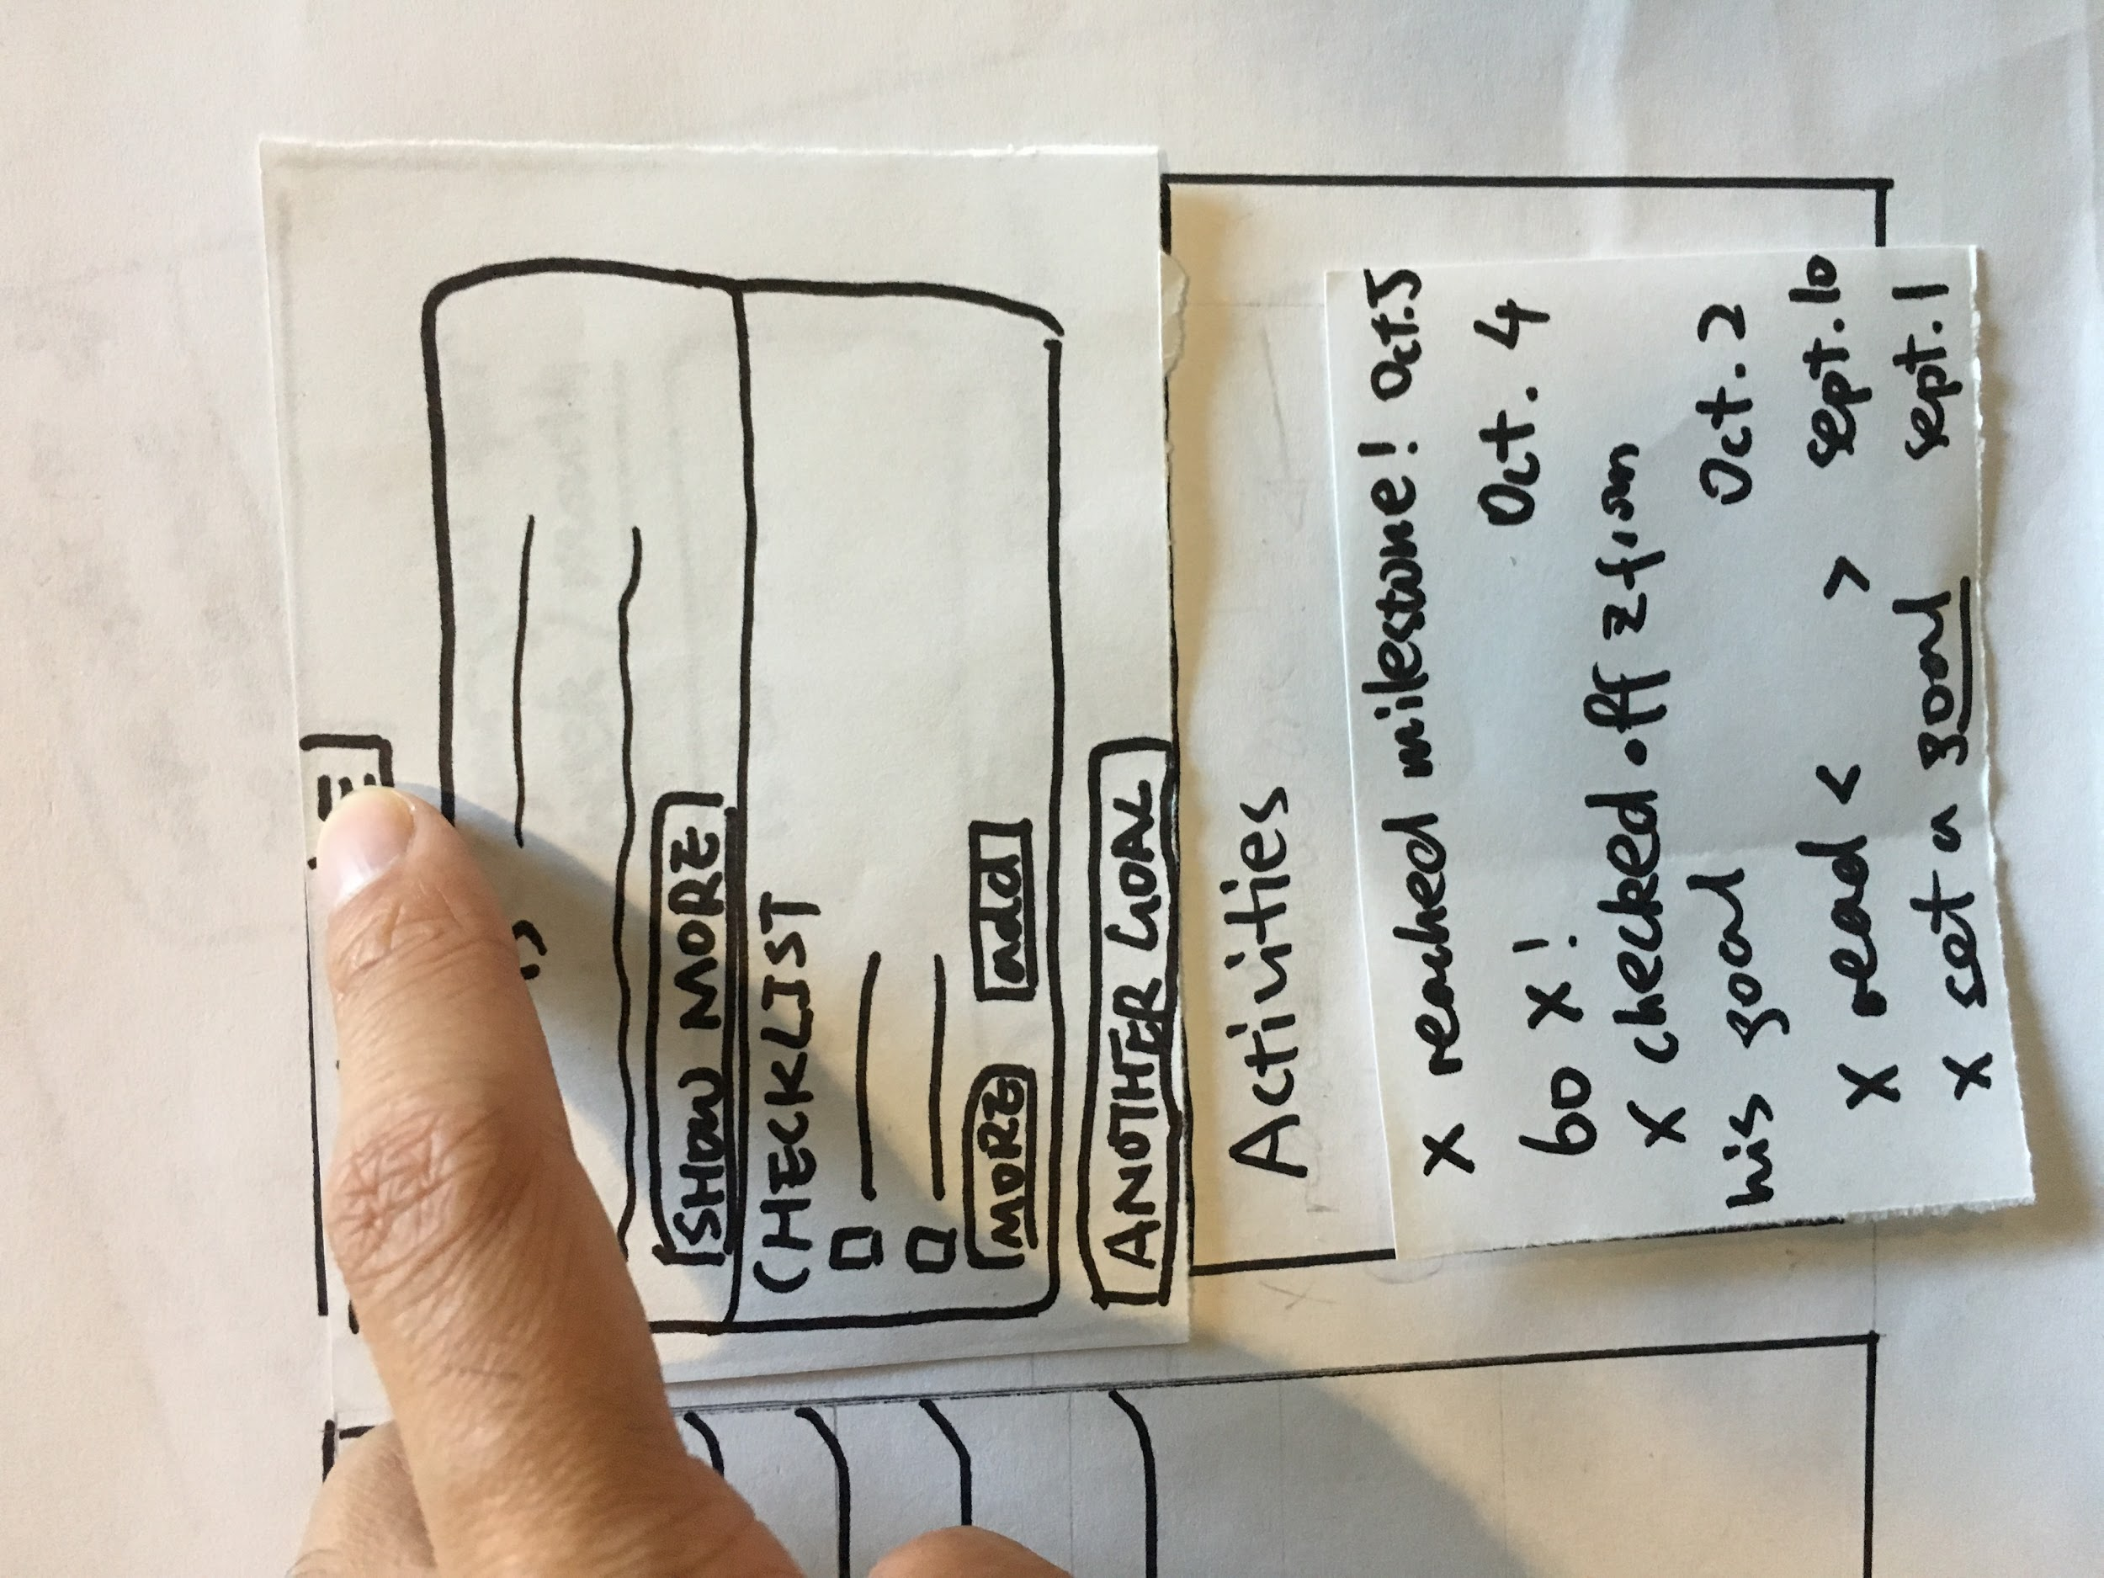

The activities will show what the user has finished doing. The user now is pull down the button to go back to categories page.



Pulling down the button on the top, the user can go back to the homepage.



The user successfully goes back to the homepage now!

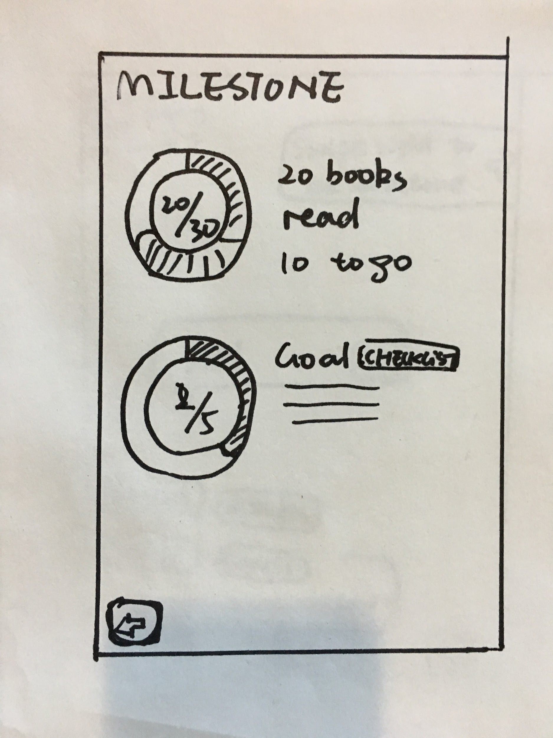

User could swipe right to see the progress of goals.

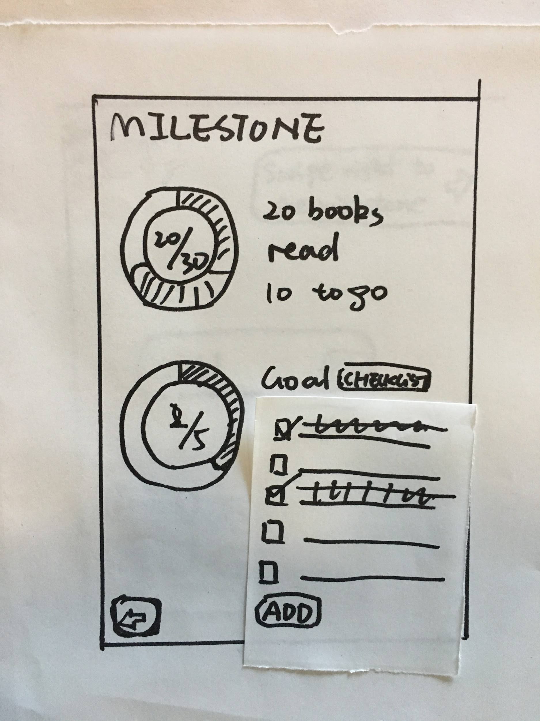

Click on check list could see the list and interact with the list.

#2

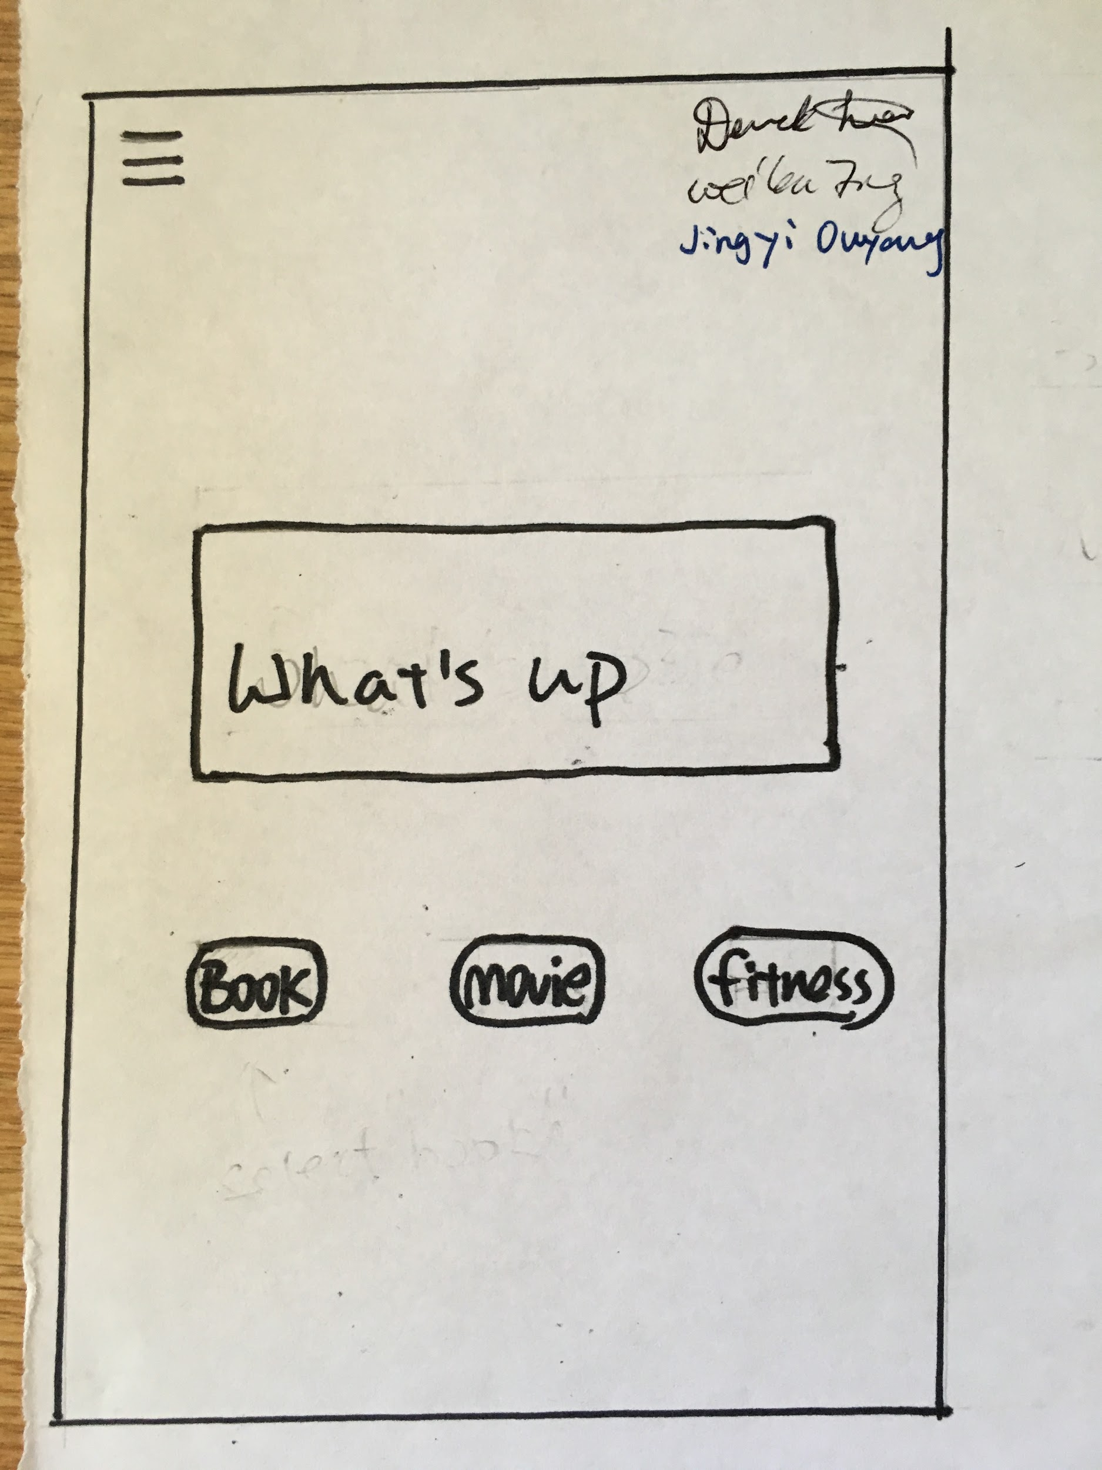

This is the homepage.

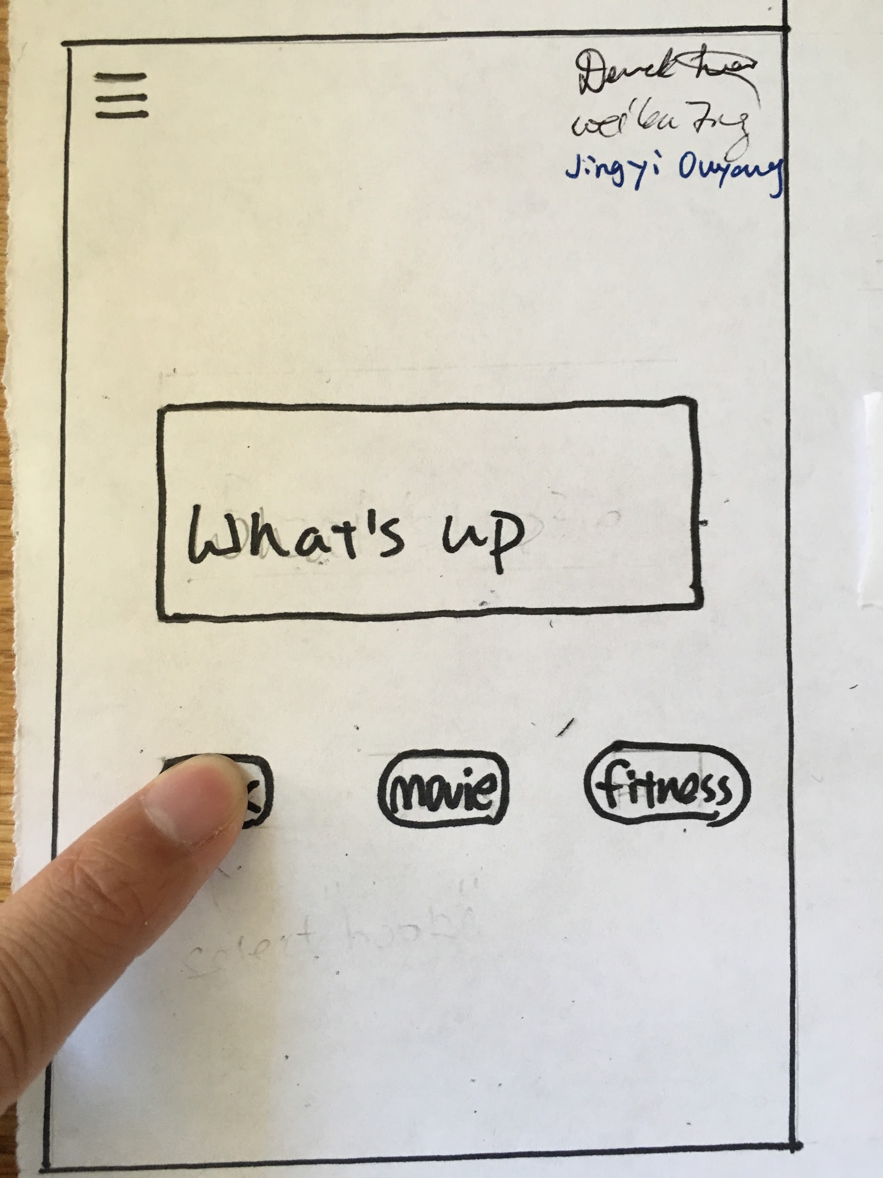

Now the user wants to add a book he has read. The user is clicking the “Book”.

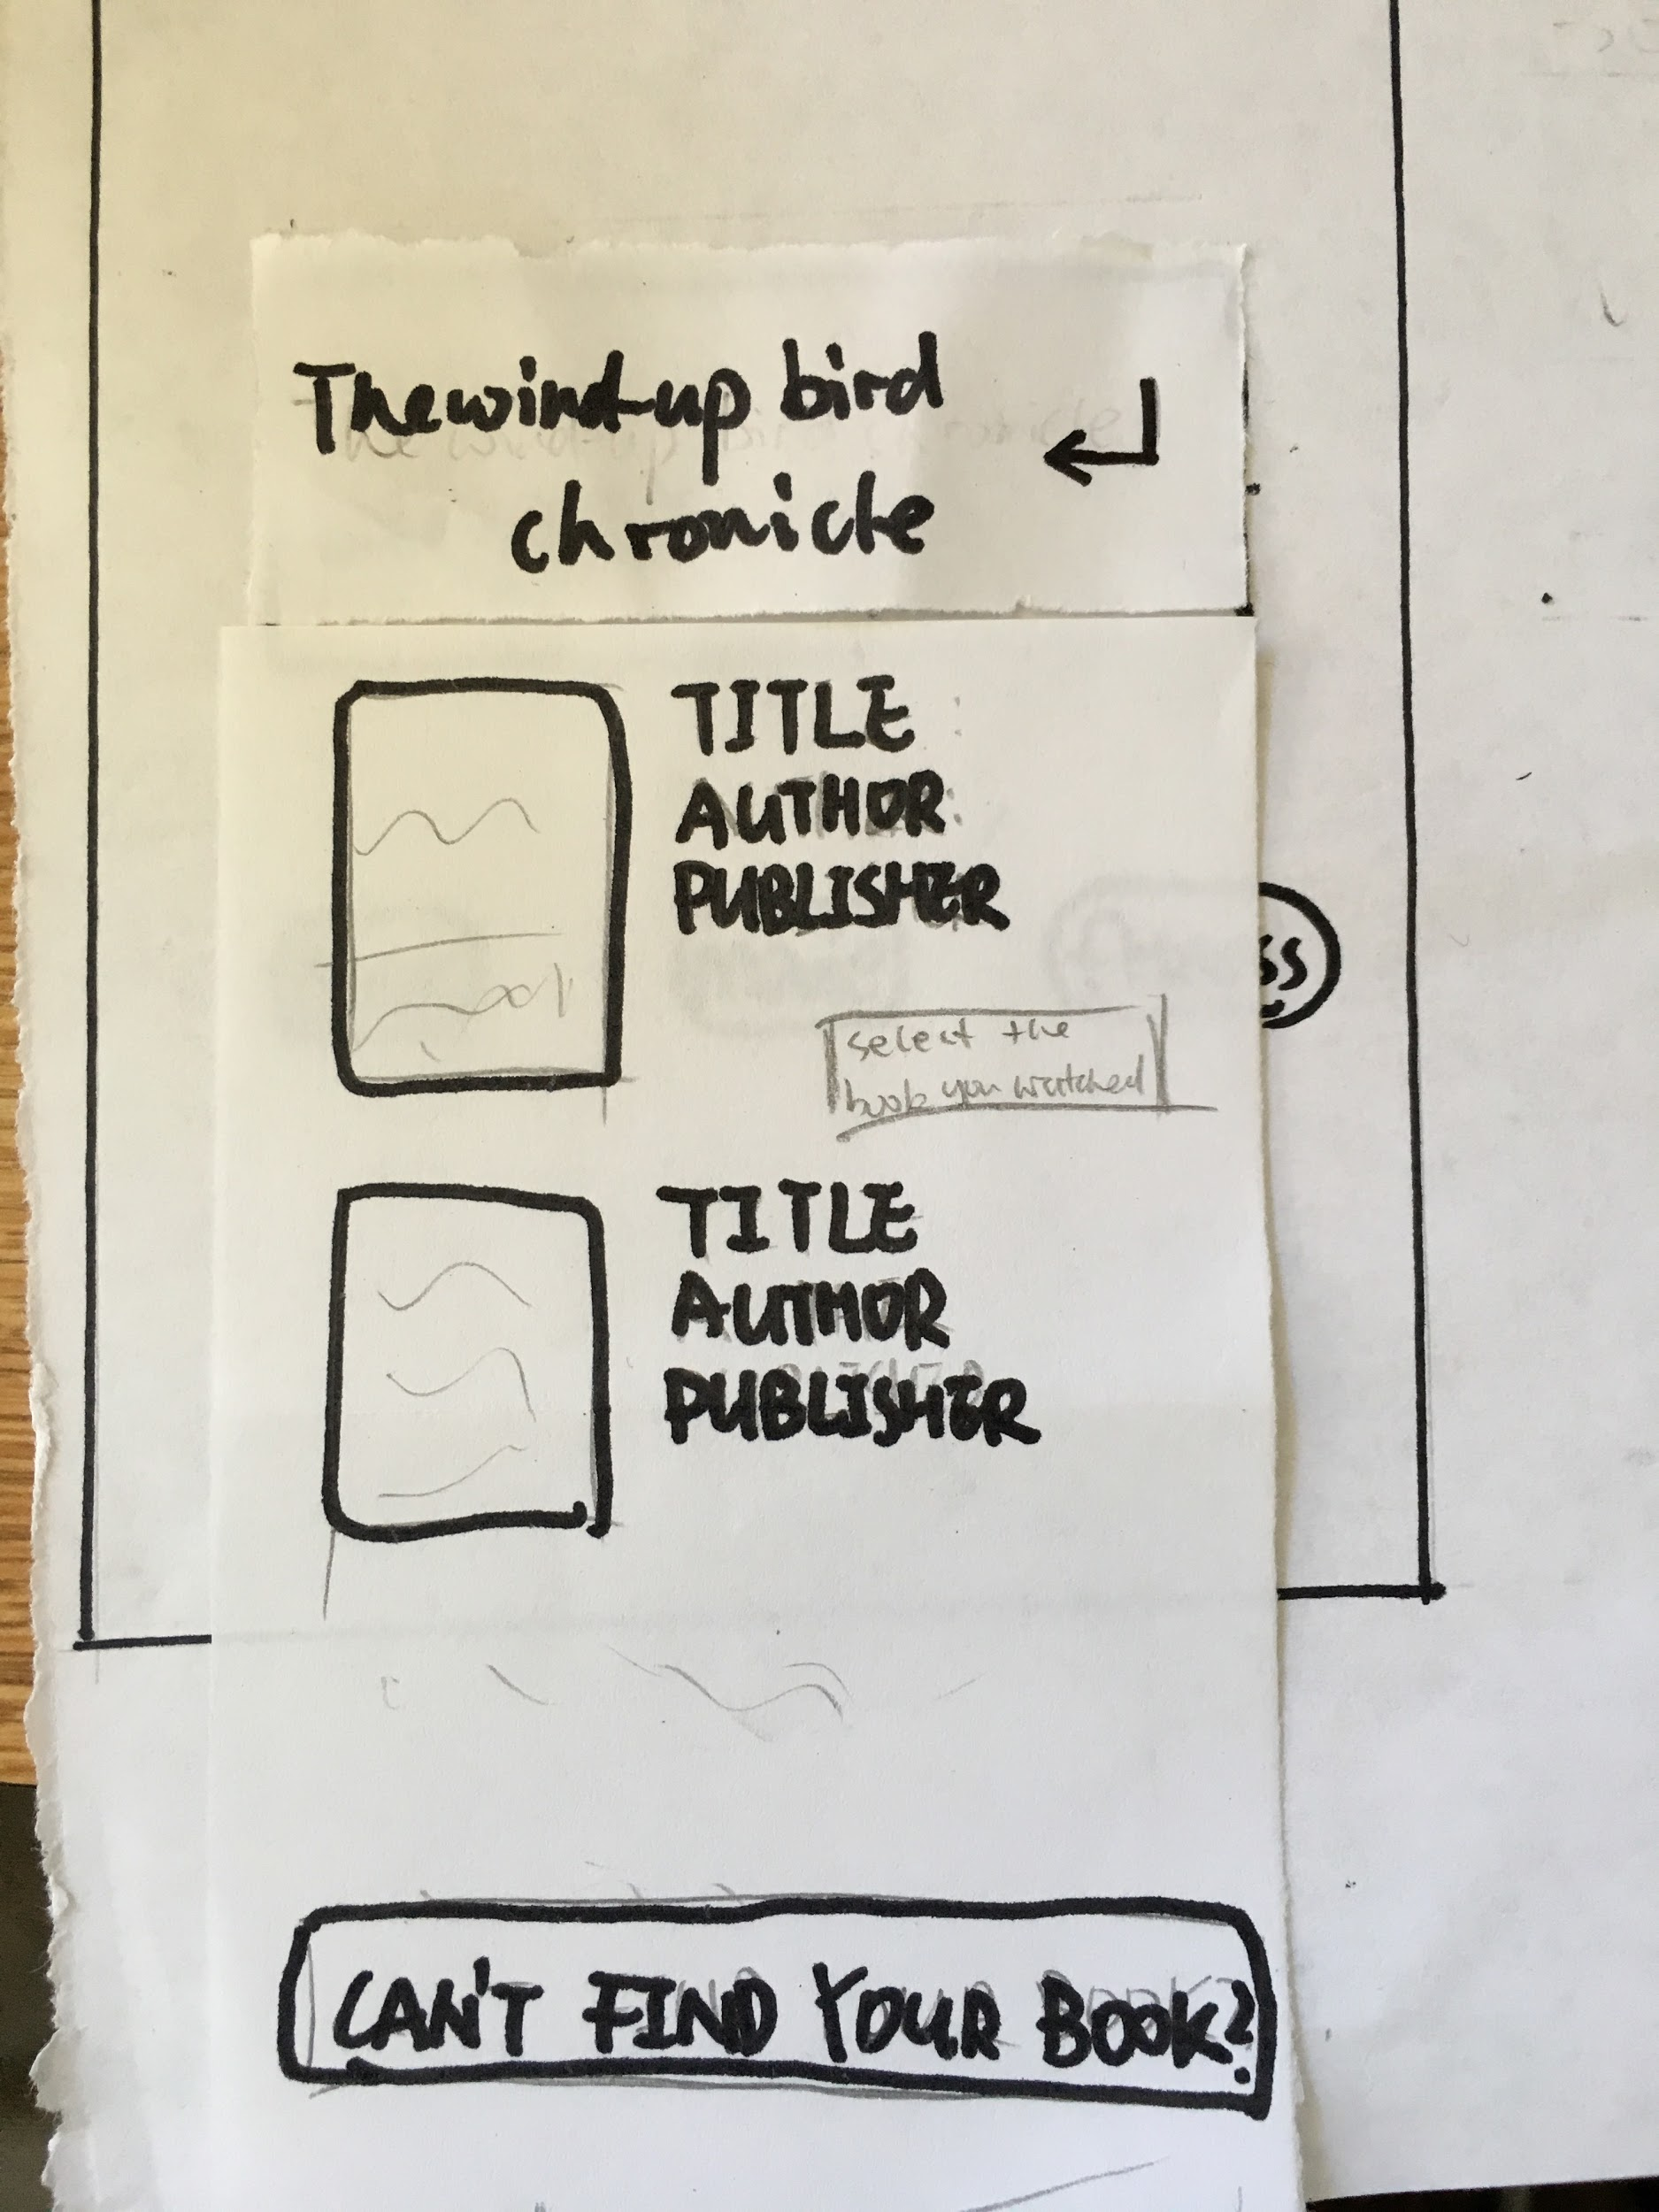

The user input the book name. The app automatically searches the book and shows relevant results

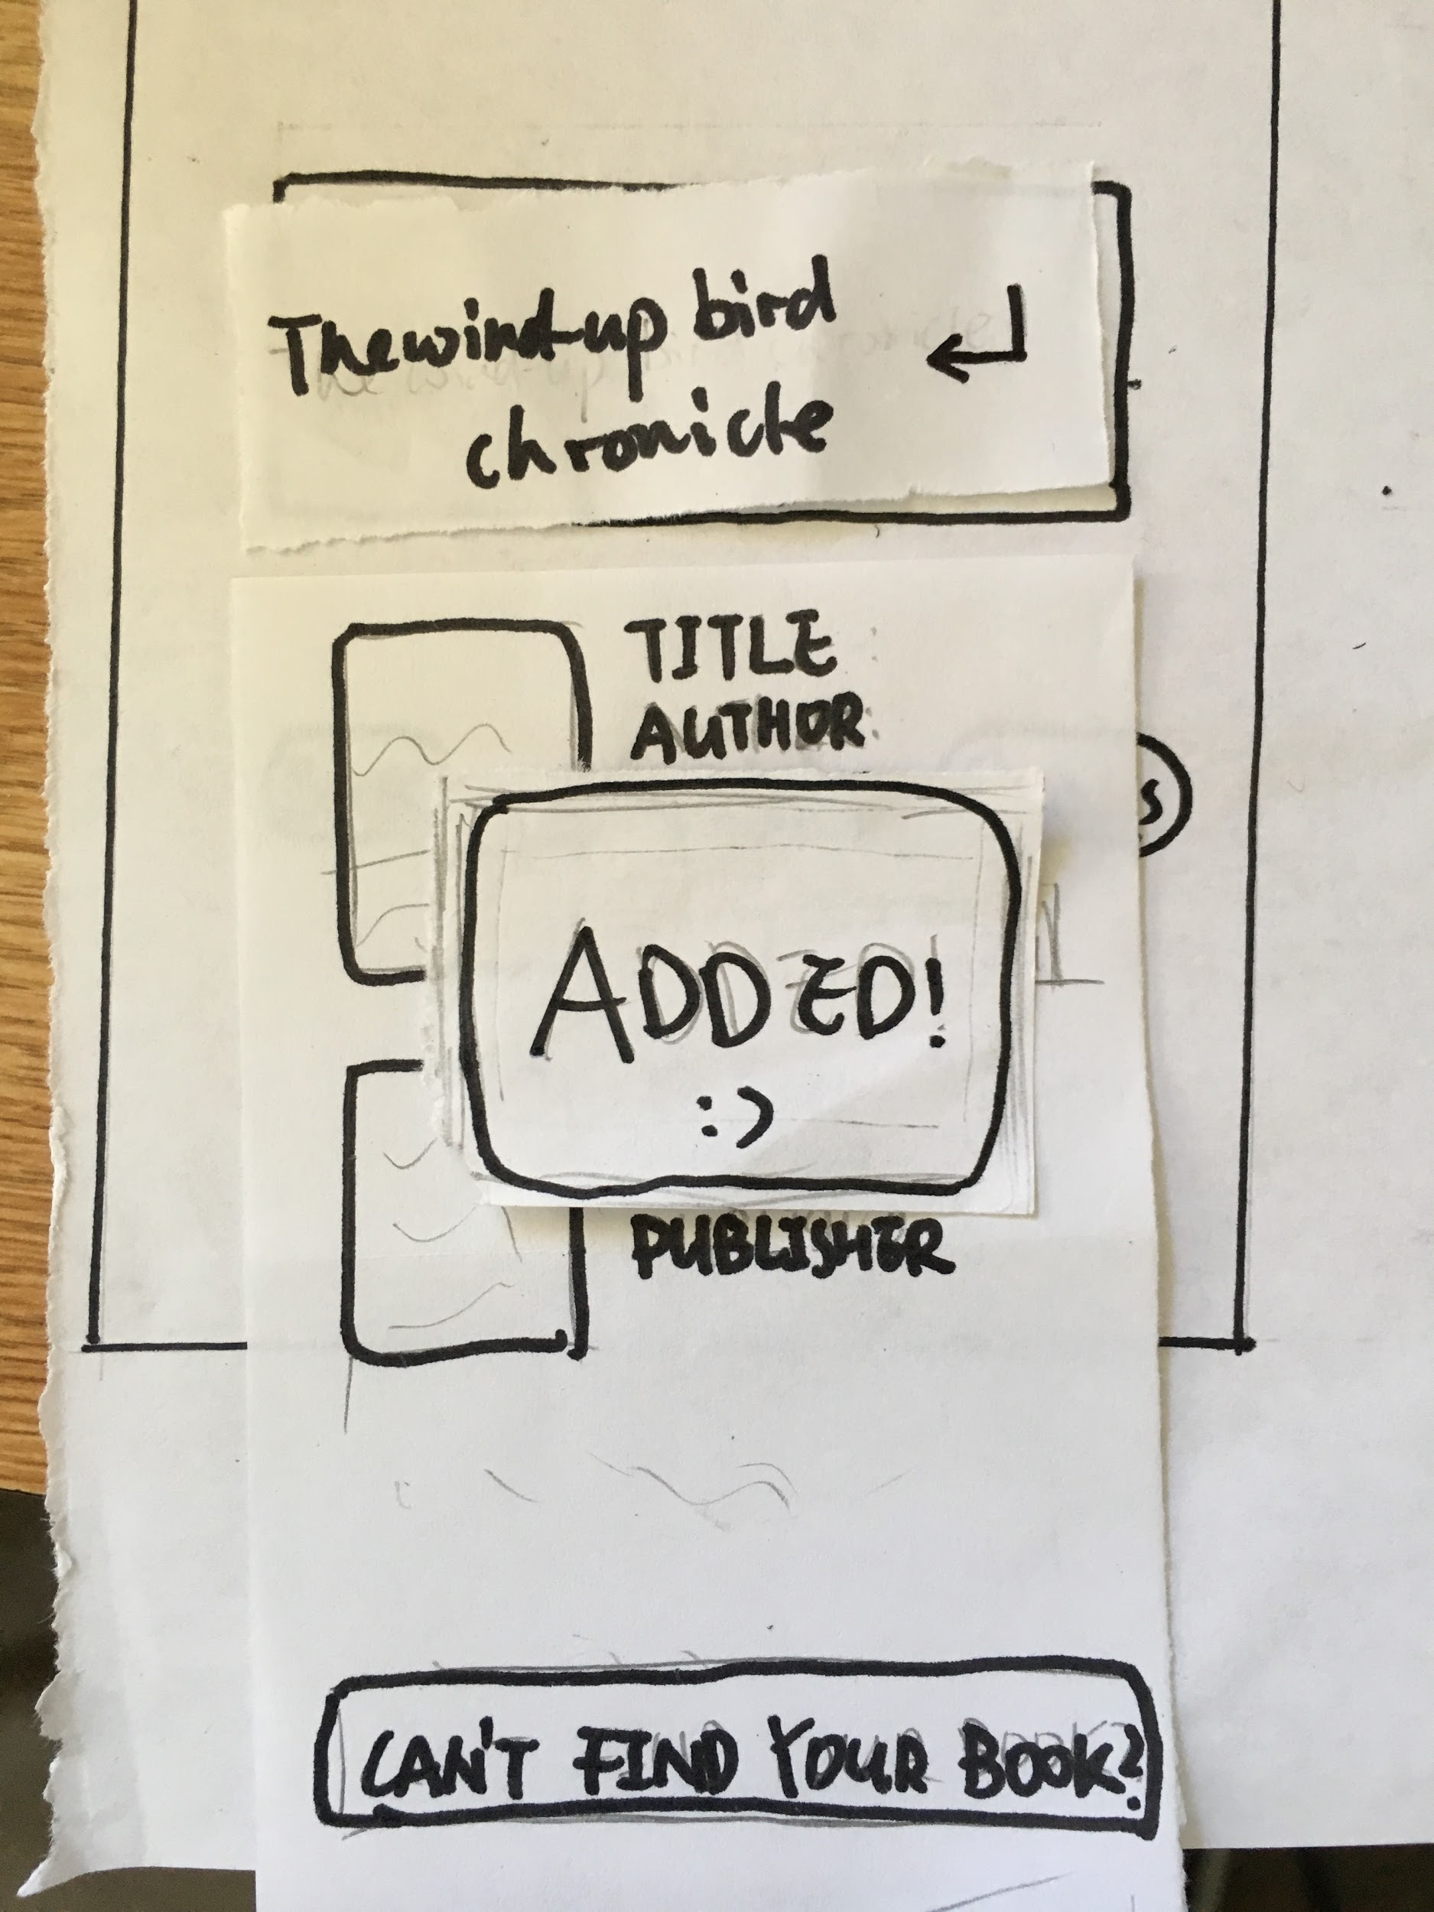

Great! The user found the one he just read. Click the book and add it into book category. If the book info is not found in database, user could manually input the book info.



Title would be automatically filled. User could add info now or later.



Successfully added item

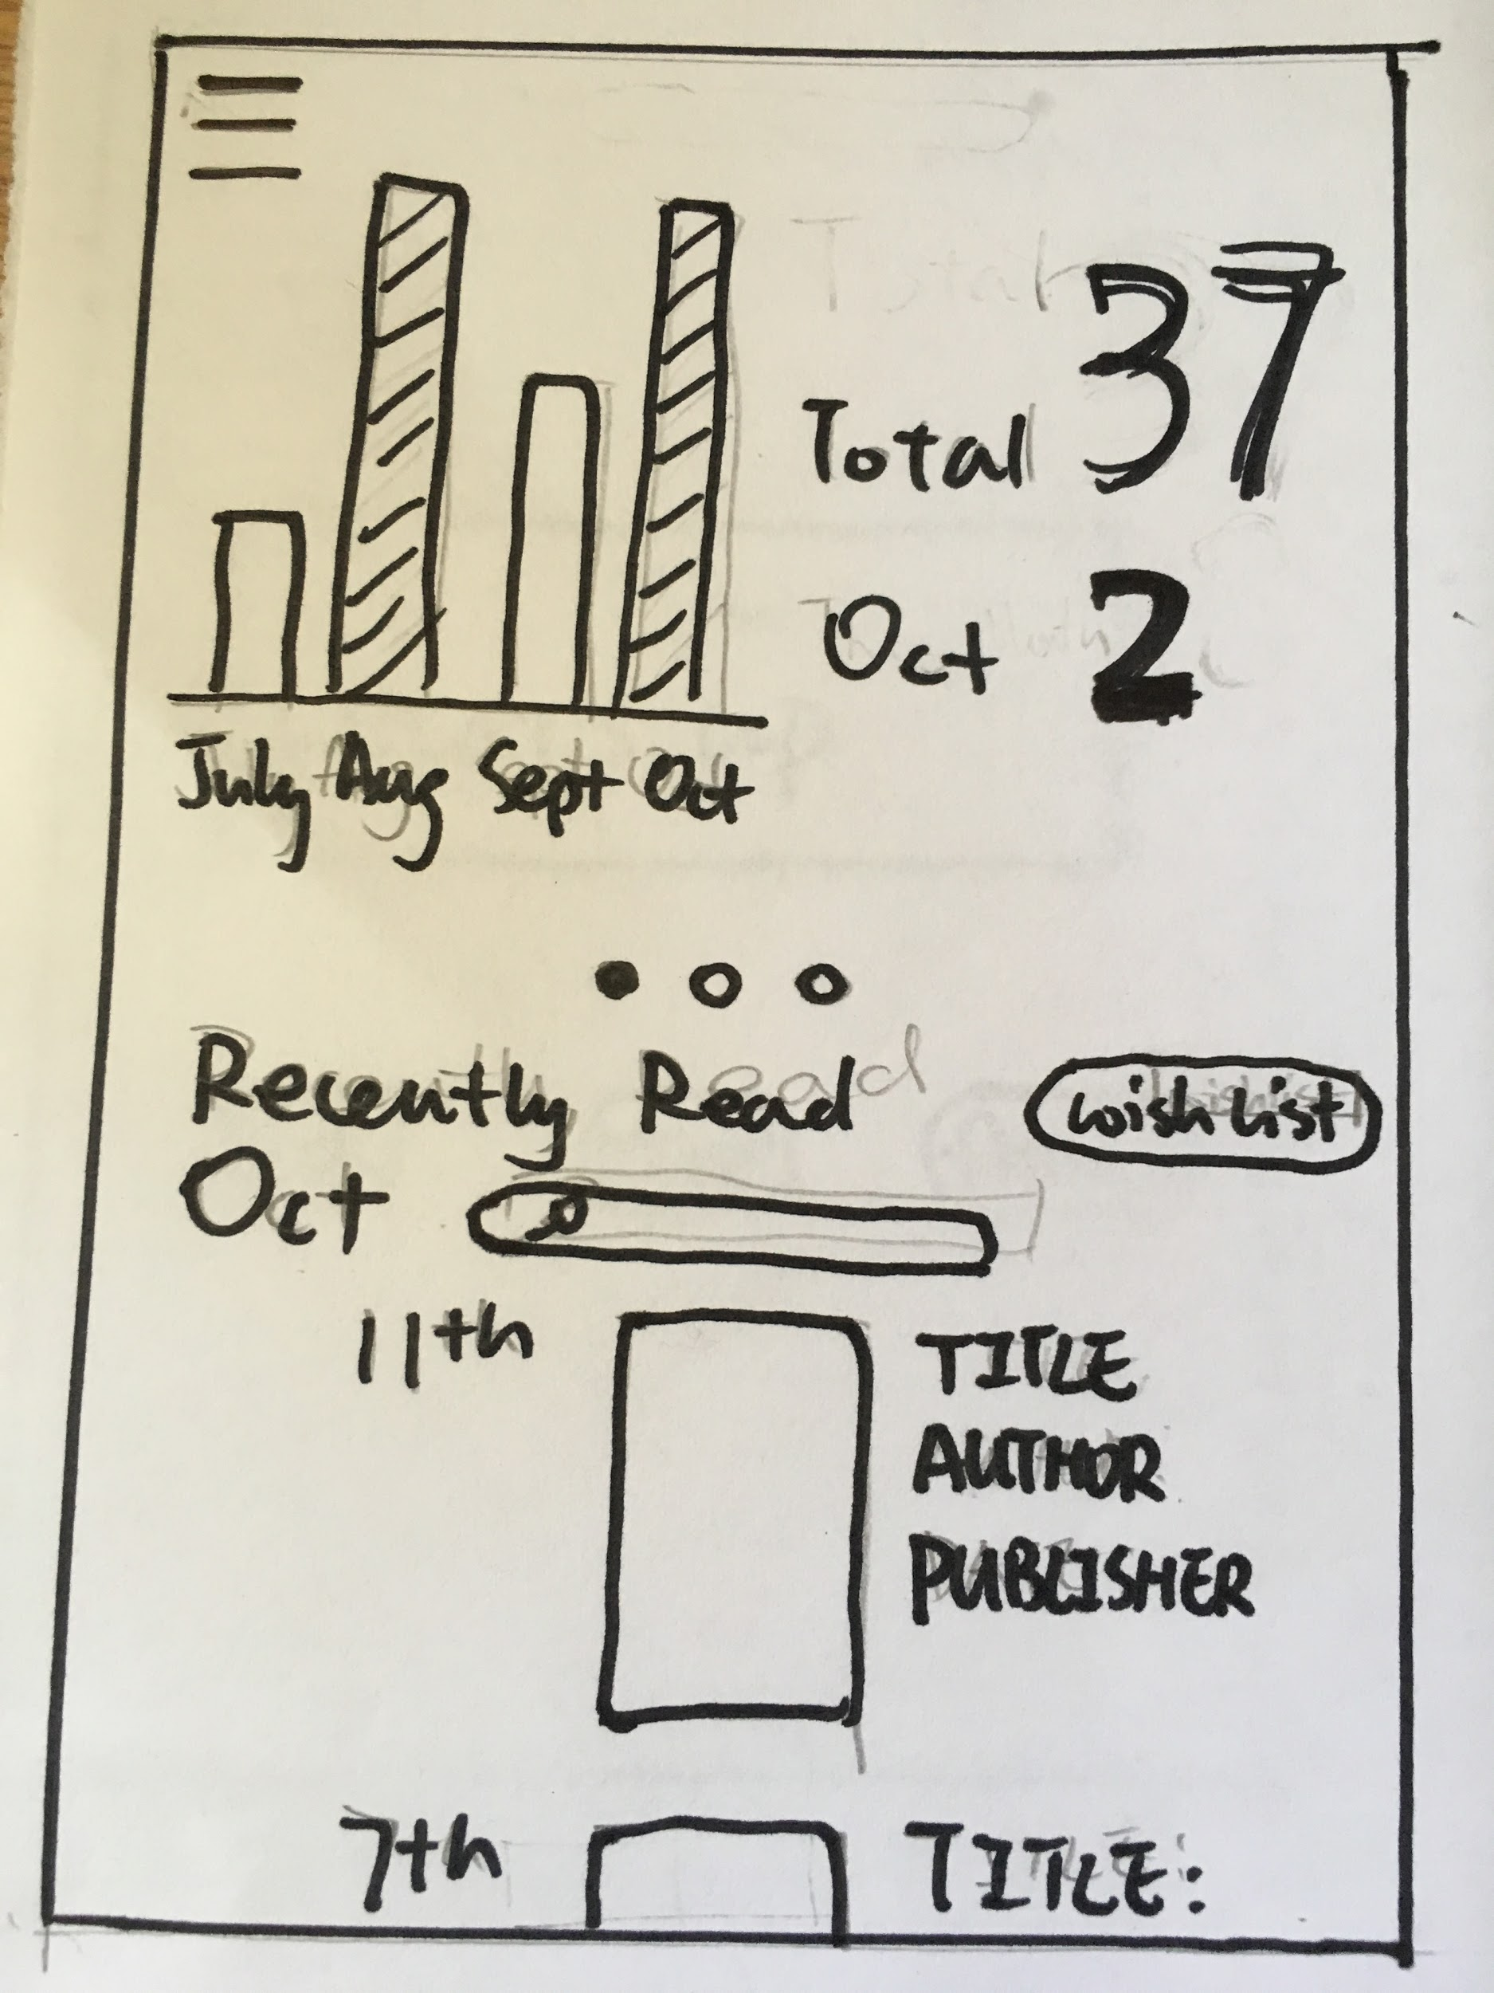

Statistical charts are shown on the top. Swipe to see different charts.

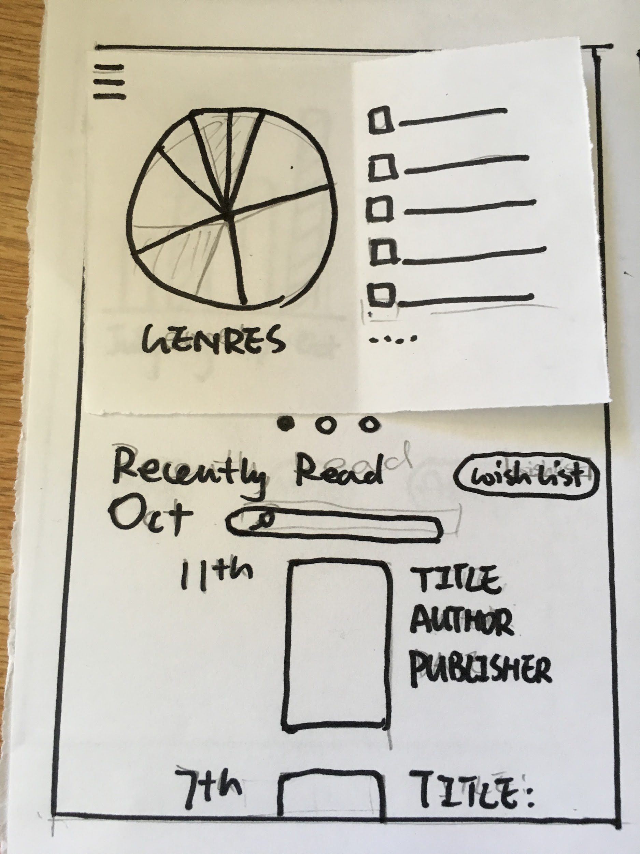

This is another kind of chart showing genres of books the user has read. Scroll up to see more about reading history

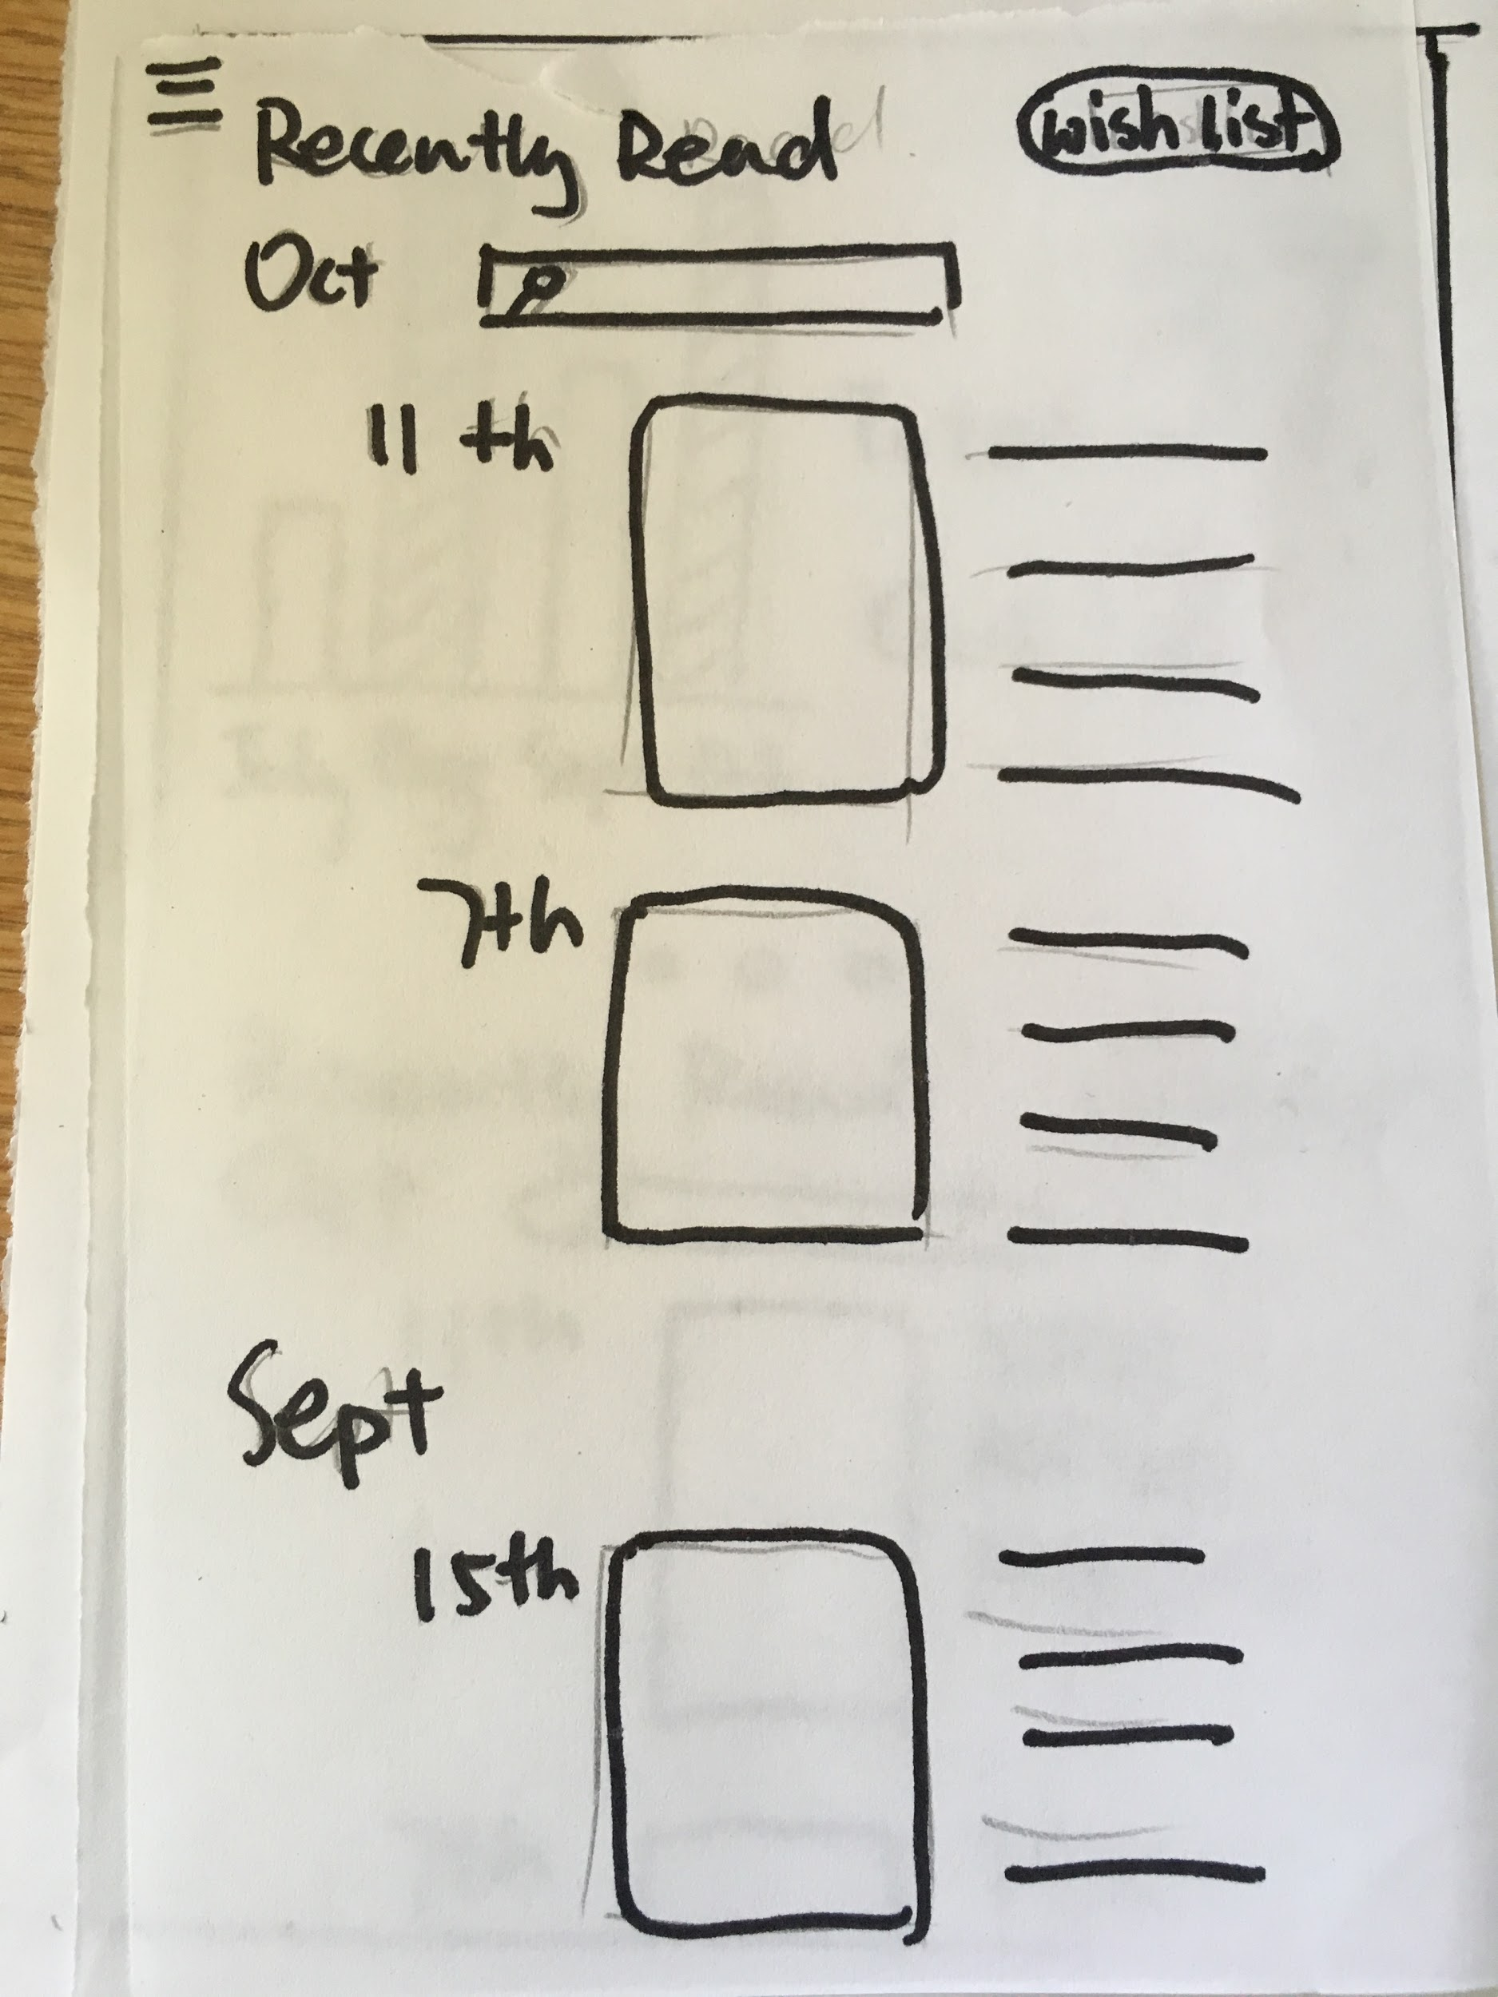

Now “histories” is shown in full screen. The user can slide the list down to find a certain book. And he also can directly search the book to quickly find it in the list. Click the “wish list” button

on the right to get into wish list.

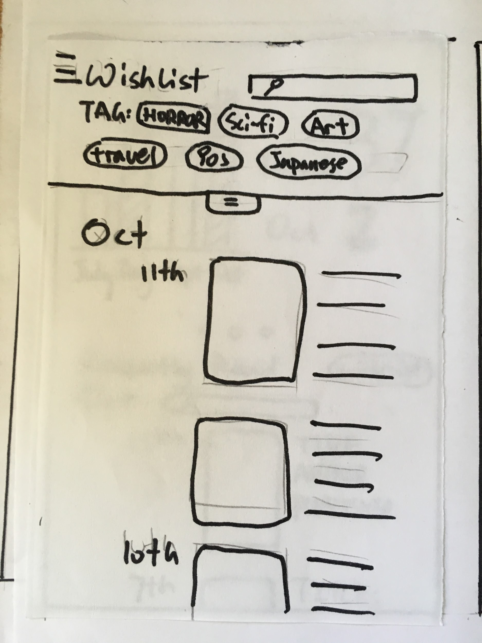

This is the wish list page! Scroll down or search to find a book. Filter is also available through self-added or auto-generated tags.

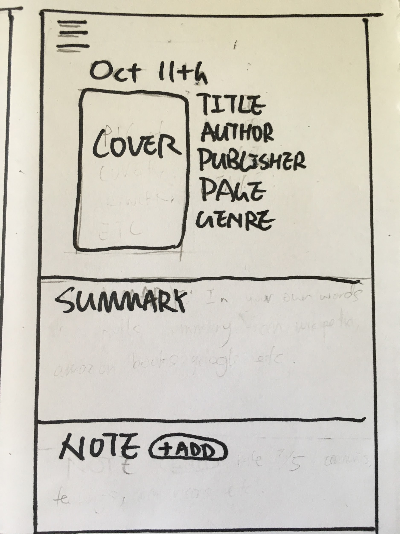

After finding the book, the user clicks the book and get into this page, which shows the details of the book. User could add notes. click the button on the top to see the navigation.

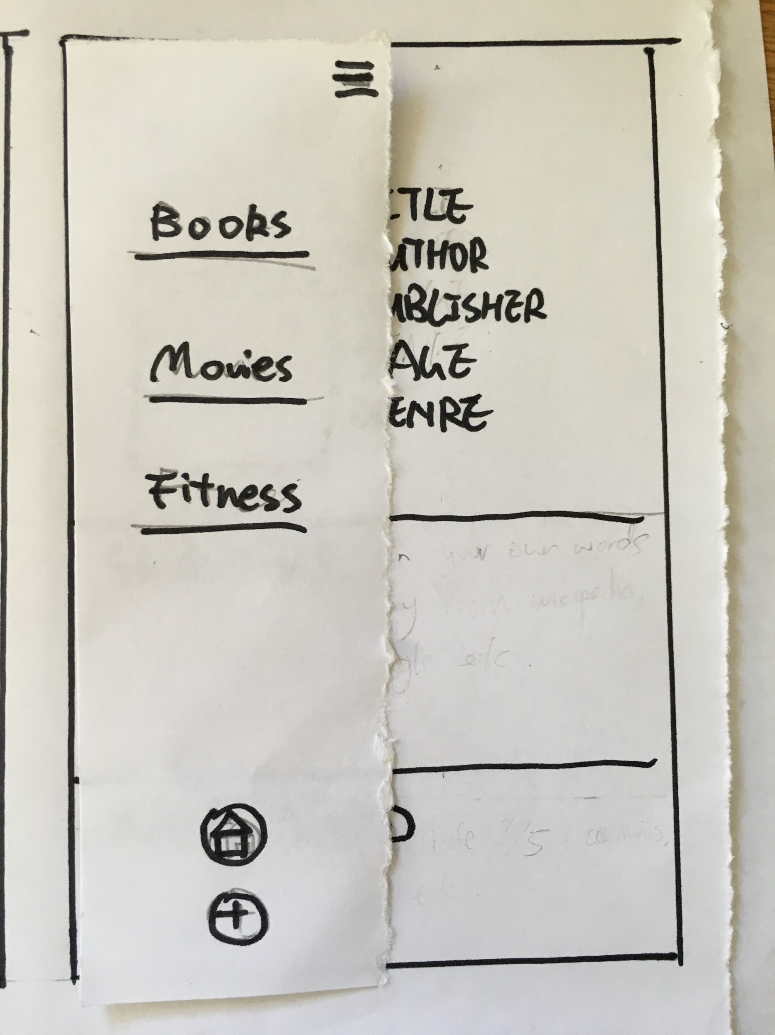

Navigation is popped out. Click categories to go to their pages. Or go back to homepage by clicking the “home” button on the bottom.

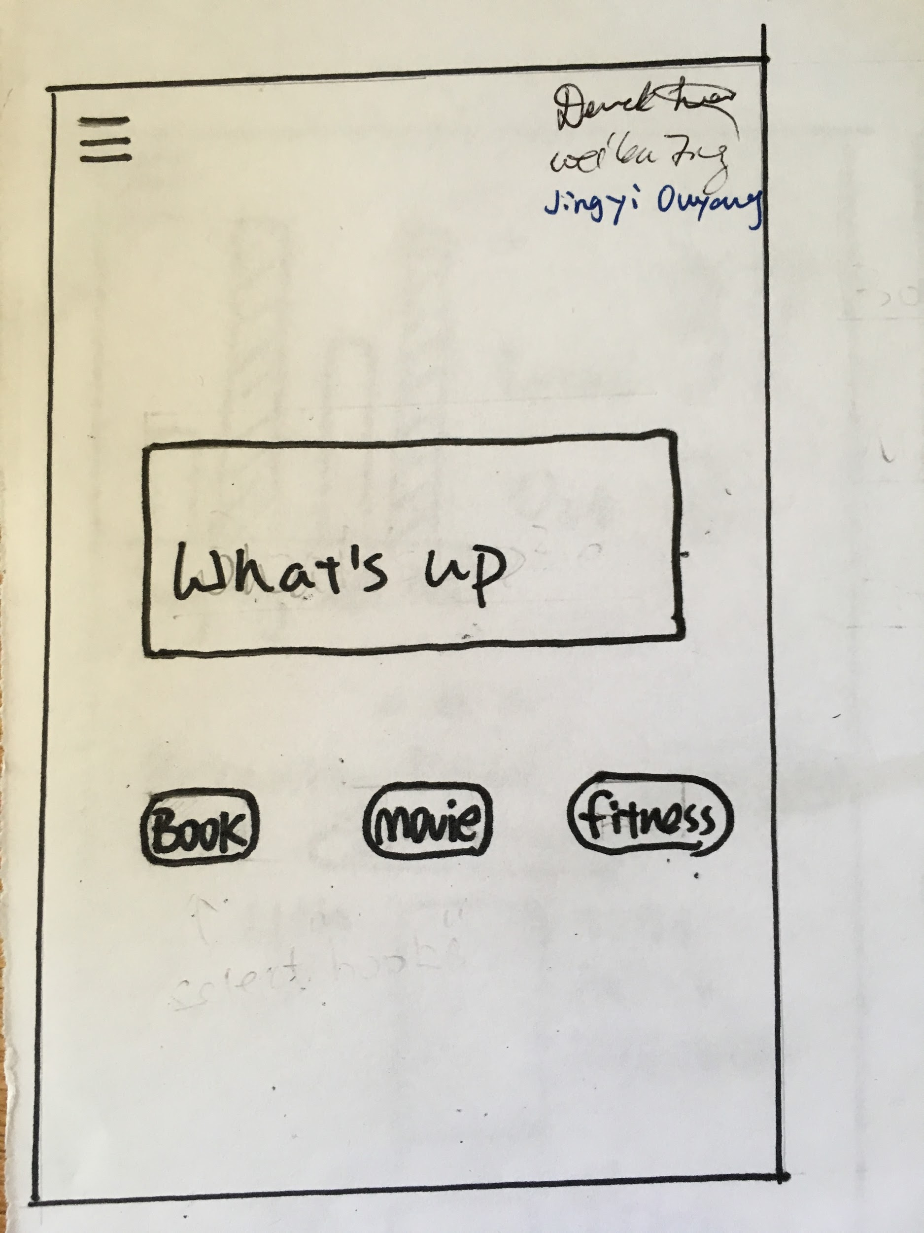

The user successfully goes back to the homepage!